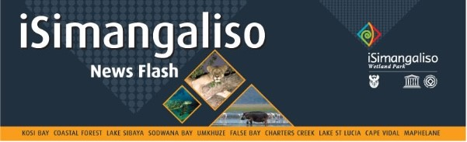
31 July 2023

iSIMANGALISO WETLAND PARK TRANSFORMING LIVES AND PROTECTING NATURE

10 years ago, iSimangaliso implemented the Environmental Education Programme. The aim of this programme is to give access to local learners from neighboring schools into iSimangaliso Wetland Park to participate in fun environmental education activities and practical learning experience. This programme lead to the fulfilment of the goal iSimangaliso has about the Environmental Education which is to bring learners from communities neighboring the Park to visit iSimangaliso Wetland Park at least once in their schooling periods. iSimangaliso also hosts more than 1500 learners in the park for Environmental Education field trips. This programme is also integrated to school awards and tree naming project in the Park. iSimangaliso through Environmental Education Programme visits approximately 70 schools with its conservation partners such as Ezemvelo KZN Wildlife.

The programme goes a long way in the creation of environmental awareness. During Environmental Education, people get to learn about the importance of protecting and conserving nature. Environmental educators also teach communities about the outstanding universal values upon which iSimangaliso Wetland Park was proclaimed as the World Heritage Site by UNESCO in 1999. They also get to know more about how unique the Park is, what are some of the conservation threats facing biodiversity, and to creating general awareness, the Environmental Education programme is also designed to provoke changes to how learners respond to their surrounding natural and cultural environment. Thus, the iSimangaliso Wetland Park Authority focuses the programme on learners in grade 7 to 9. At this stage in their school career, they are required to learn critically and reflectively within a range of different subjects. iSimangaliso focuses on these grades for both school visit and Park visit.

The selection of these grades also ensures the alignment with the bursary programme of iSimangaliso, as it is expected in such grades for leaners to choose career paths that are in line with conservation and tourism. The Environmental Education programme also seeks to support the schools with learning programmes. This is achieved through the alignment of the programme with the school curriculum. Ahead of developing or reviewing the Environmental Education materials, consultation with the Department of Education takes place to ensure the programme alignment.

Through assistance of the stakeholder engagement managers, the Environmental Education and Awareness programme also reach out to the different traditional leaderships across the Park. This helps iSimangaliso in creating Environmental Awareness to leaders of communities living in and adjacent to the Park. In terms of ensuring the participation of youth in the awareness programme, iSimangaliso works with community-based youth like Rhino ambassadors who deal with diverse audiences in their respectful communities to distribute conservation message after receiving intensive training from iSimangaliso awareness team.

iSimangaliso Environmental Educator Mr Sifiso Vumase was born and bred in one of the communities neighbouring iSimangaliso (uMhlabuyalingana) in a place known as Kwandaba under Tembe Traditional leadership. In 2014, Mr Vumase joined iSimangaliso Internship programme after he obtained his B-Tech in Tourism management. He was then appointed by iSimangaliso as the Environmental Education officer, of which his role is to educate different stakeholders about the importance of Biodiversity conservation. Mr Vumase and his 4 interns from the 200 Groen Sebenza internship programme take learners into the Park and visit schools to educate learners about the importance of conserving nature while participating in environmental awareness campaigns..

-END-

Statement issued by iSimangaliso Wetland Park Authority
Media enquires:
Mr. Bheki Manzini
Call/WhatsApp: 060 533 2082
Email: bhekimanzini@isimangaliso.com

