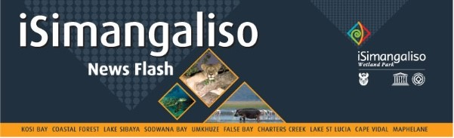

**29 May 2024**

**iSimangaliso celebrates International Day for Biological Diversity with Monzi Primary School**

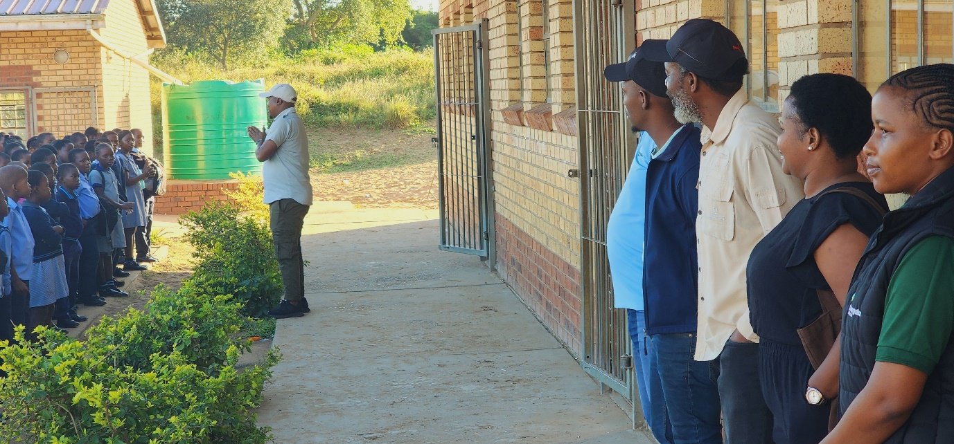

iSimangaliso partnered with Ezemvelo KZN Wildlife, iSolemvelo conservation trust, Youth Rhino ambassadors and Greenvalley Recycling Systems in visiting one of the schools neighbouring iSimangaliso called Monzi Primary School to celebrate International Day for Biological Diversity. This celebration gave different stakeholders an opportunity to engage with learners on different biodiversity related topics with the hope to inspire young minds and instil a sense environmental stewardship among the learners of Monzi Primary School.

The Theme for this year was “Be Part of the Plan” to halt and reverse biodiversity loss. It calls for all stakeholders to act for Biodiversity and also seeks to increase understanding and awareness of Biodiversity issues. Topics such as what is Biodiversity, importance of biodiversity, ecological and commercial role, conservation threats and the role to be played by the learners in the protection of biodiversity were covered by different speakers from various stakeholders.

Prior to the celebration of the International Day for Biological Diversity, iSimangaliso celebrated World Bee Day on 20 May 2024. The theme for this year’s Bee Day was “Bee engaged with youth”. This theme seeks to indicate the importance of involving youth in beekeeping and pollinator conservation efforts recognising them as catalyst in our environment. iSimangaliso Environmental Educator Mr Sifiso Vumase, gave some insight on the ecological and commercial importance of bees and the role to be played by the youth in addressing challenges bees and other pollinators face.

South Africa is home to three recognized and renowned biodiversity hotspots, namely Cape Floristic region, succulent Karoo, and the Maputaland-Pondoland- Albany Hotspot. The Maputaland-Pondoland- Albany Hotspot is covered under iSimangaliso Wetland Park- World heritage Site and it boast different animals and plants species and some of them cannot be found anywhere else. Therefore, iSimangaliso has created a list of environmental days to be celebrated in different schools to foster love for nature and nurture generation of conservation minded generation who will protect South Africa’s natural heritage.

In an effort to intensify the message delivered during World Bee Day and International Day for Biological Diversity, iSimangaliso committed to continue taking learners to the park to have close interaction with nature. Learners are going to be provided with free transport and refreshments. The section of the park to be visited is eastern shores section of the iSimangaliso Wetland Park.

**END**

**End Statement issued by iSimangaliso Wetland Park Authority**

Media enquires

MLO: Mr Bheki Manzini

Call/WhatsApp:060 533 2082

Email: bhekimanzini@isimangaliso.com