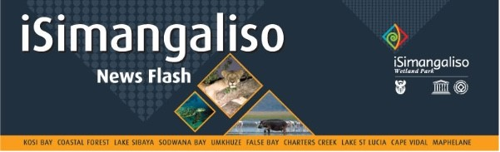

29 kuNhlaba 2024

**iSIMANGALISO SIBUNGAZE USUKU OLUBALULEKILE NGOKUBAMBISANA NESIKOLE SAMABANGA APHANSI**

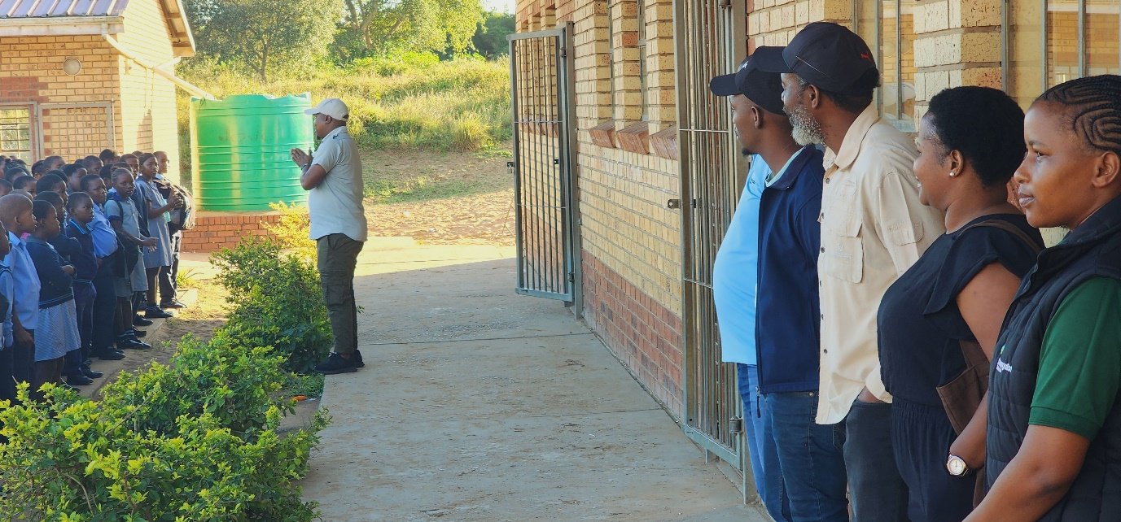

iSimangaliso sibambisane neZemvelo KZN Wildlife, iSolemvelo conservation trust, Youth Rhino ambassadors kanye *ne-Greenvalley Recycling Systems* sivakashele esinye sezikole esingumakhelwane nepaki esaziwa ngokuthi yiMonzi Primary School ukubungaza usuku olubaluleke kakhulu olwaziwa ngokuthi *yi-International Day for Biological Diversity*. Lo mbungazo unike ithuba ababambe iqhaza abahlukene ukuthi baxoxisane nabafundi ukudingida izindaba ezihlobene nemvelo ehlukahlukene ngethemba lokuthi abafundi bazoba nogqozi kanye nolwazi mayelana nokuphathwa kahle kwemvelo.

Isiqubulo sakulo nyaka besithi, “*Yiba yingxenye yohlelo*” lokuvimba kanye nokuhlehlisa wonke umonakalo obe kwimvelo. Kushaywa ikhwela kubo bonke ababambe iqhaza ukuba bathathe igxathu mayelana nokuvikelwa kwemvelo kanye nolwazi lokuqonda kabanzi izinkinga ezibhekene nemvelo. Izihloko ezifana nokuthi ziyini ezemvelo ngokuhlukana kwazo (Biodiversity), ibaluleke ngani *leyo-biodiversity*, yiliphi iqhaza elibanjwe i*-ecological and commercial*, ukusabela imvelo kanye neqhaza elingabanjwa ngabafundi ukuvikela imvelo kube izihloko ebezidingidwa izikhulumi ezahlukene.

Ngaphambi kokubungazwa kwalolu suku, iSimangaliso sibungaze usuku olwaziwa ngokuthi *yi-World bee* *day* nokungusuku lokubungaza iZinyosi ezweni lonke ngomhlaka 20 kuNhlaba 2024. Isiqubulo salolu suku sona sasithi, “*Izinyosi zihlanganyela nentsha*”. Lesi siqubulo sasihlose ukuveza ukubaluleka kokufaka intsha ezinhlelweni zokuvikelwa kwezinyosi kanye nokubonakala kwentsha njengabantu abamqoka ekuvikelweni kwemvelo. UMnuz. Sifiso Vumase (iSimangaliso Environmental Educator), wabe eseveza ubumqoka bokuhweba ngezinyosi kanye neqhaza elingabanjwa intsha ukwethula izinselelo ezibhekene nokuzalana kwezinyosi.

iNingizimu Afrika iyikhaya lezinhlobo ezintathu ezaziwayo nge-*Biodiversity* okuyilezi; *yi-Cape Floristic region,* succulent *Karoo*, kanye *neMaputaland-Pondoland-Albany Hotspot*. *I-Maputaland-Pondoland-Albany Hotspot* ingaphansi *kweSimangaliso Wetland Park-World heritage* futhi le ndawo isiza kakhulu nokuba nezilwane ezahlukene ezingatholakali kwezinye izindawo. Ngakho-ke, iSimangaliso sinohlu lwezinsuku ezibungazwayo ngokubambisana nezikole ezahlukene ukufaka uthando lwemvelo kubafundi kanye nokubakhulisa ngokomqondo mayelana nokuvikelwa kwemvelo.

Emizameni yokuqinisa nokusabalalisa ulwazi olwethulwe ngalezi zinsuku, iSimangaliso sazibophezela ukuthi sizoqhubeka nokuthatha abafundi sibalethe epaki ukuze bezofunda kabanzi ngemvelo. Abafundi bazolandwa mahhala ngezimoto bephinde benikwe nokudla. Bazovakashela ingxenye esogwini oluseMpumalanga lwepaki.

-Iyaphela-

**Isitatimende sikhishwe iSimangaliso Wetland Park Authority**

**Abezindaba bengaxhumana no:**

MLO: Mr Bheki Manzini

Call/Whatsap: 060 533 2082

Email: bhekimanzini@isimangaliso.com