**May 2024**

**GEF SGP PROVIDES TRAINING TO FUNDED CO-OPERATIVES WITHIN iSIMANGALISO**

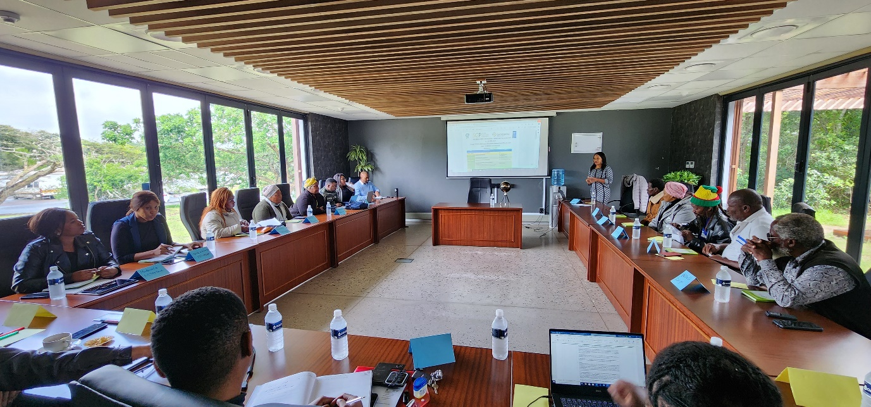

The Global Environment Facility (GEF) Small Grants Programme implemented in South Africa by UNDP in partnership with iSimangaliso Wetland Park, signed grant funding support agreements totalling US$135,000 (approx.R2,529mill) to three Co-operatives in January 2024 and their first payments were released between February and March 2024.). As part of ensuring proper use of funds at the reporting stage, iSimangaliso and GEF SGP hosted a Report Writing Worshop (narrative and financial) for the three grantees. iSimangaliso and the GEF SGP once held a workshop on the 13th to the 14th of July 2023 at Hluhluwe to assist civil society organisations and local small business owners in completing the project proposals for the GEF Small Grants Programme.

The successful grants applicants are Nibela Fisheries Co-operative, Siyazama St. Lucia Market Primary Co-operative, and Dukuduku-Khayelisha Fisheries Co-operative. Nibela Fisheries and Siyazama St. Lucia Market Primary Co-operative received their first tranche on the 27th of February 2024. Dukuduku-Khayelisha Fisheries Co-operative received their first tranche on the 6th of March 2024. Nibela Fisheries Co-operative and Dukuduku-Khayelisha Fisheries Co-operative are small community projects which focus on trading raw fish and processed fish products. Through this grant support, they intend to buy fully equipped fishing boats and material which will assist them to be commercial fishers. Siyazama St. Lucia Market Primary Co-operative is a women-owned craft market situated in St. Lucia town. They offer craft work and fresh produce products to tourists. They intend to use the GEF SGP funding to renovate their market structure which was becoming a safety hazard to tourists and the crafters. .

Mr Nkuna who is the chairperson of Nibela Fishing Co-operative speaking on behalf of the 3 granted co-operatives in the meeting said they appreciate the continued support that they receive from iSimangaliso and GEF SGP. “’ I would like to thank all parties involved in this programme, I can see the intention is to change our lives for the better. I would also like to appreciate that our proposal was approved and we have received the first tranche. Honestly speaking, our project just started working because we did not have money. There is a lot that is going to change in our business and our lives”, said Mr Nkuna.

The 3 projects are part of the first 15 community wildlife economy projects supported by the GEF SGP across the nodal areas of iSimangaliso Wetland Park, Kruger National Park and Greater Addo-Amathole contributing towards the implementation of the National Biodiversity Economy Strategy (NBES). There are various project still to be implemented within iSimangaliso through the GEF-7 project. These projects includes the rehabilitation of the Mabasa Community Conservation Area, Makhasa Community Conservation Area and Kosi Bay tourism precinct development and etc. The SGP provides grant funding to communities and civil society organizations to enable them to implement projects in conservation of the environment and climate change while improving their livelihoods.

**Statement issued by iSimangaliso Wetland Park Authority**

**For Media Inquiries Contact :** Mr Bheki Manzini

Call/WhatsApp: 060 533 2082

Email: [bhekimanzini@isimangaliso.com](mailto:bhekimanzini@isimangaliso.com)