**30 kuLwezi 2023**

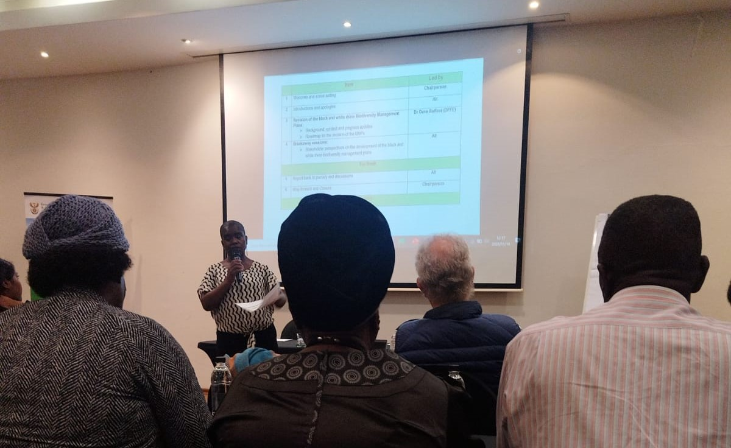**UKUBUYEKEZWA KOHLELO LOKULAWULWA KOBHEJANE ABAMNYAMA NABAMHLOPHE KUTHELE IMIPHUMELA EMIHLE**

iSimangaliso Wetland Park Authority kanye nomnyango Wezamahlathi, Ezokudoba kanye nezeMvelo (DFFE) simeme ababambe iqhaza eSimangaliso ukuba kuzoxoxiswana mayelana nokubuyekezwa kwezinhlelo zokulawulwa koBhejane abaMnyama kanye nabaMhlophe. Lo mhlangano wokuxoxisana wawubanjelwe eMkhuze okungenye ingxenye yeSimangaliso Wetland Park. Lokhu kuxoxisana bekuhlelwe izifundazwe ezinhlanu, okuyisifundazwe sakwaKwaZulu Natali, Limpopo, Mpumalanga, Eastern Cape kanye neNorth West. Lokhu kuza ngemuva kwamavikana ambalwa iSimangaliso ngaphansi kohlaka lwe-GEF-7 kanye nomnyango wakwa-DFFE beqeda kuhambela zonke izindawo zeSimangaliso ezinoBhejane, inhloso yalokho kwakuwukubheka kanye nokuqinisa izinsiza ezilekelela ukuqinisa umthetho ukuze kuqikelelwe ukuthi oBhejane baphephile.

Umnyango wakwa-DFFE wanquma ukuthi uqale ngokuxoxisana nababambe iqhaza ukuze bonke babe neqhaza ekwakhiweni kwalolu hlelo lokulawulwa koBhejane abaMnyama nabaMhlophe. Lokhu kungenxa yokuthi uhlelo olukhona lwakhandwa ithimba longoti nochwepheshe kuxoxiswane kancane kumbe kungaxoxiswananga nhlobo nemiphakathi ehlala ezindaweni ezisondelene nezindawo ezivikelwe okuyilapho kuhlala khona lezi zilwane.

Umnyango wakwa-DFFE uqoke ungoti ukuba angamele lokhu kuxoxisana nemiphakathi. Ababambe iqhaza ababemenyiwe kwakuyilaba; Ezemvelo KZN Wildlife, iSimangaliso Wetland Park, kanye nomnyango wakwaDFFE. iSimangaliso sabe seselula isimemo emiphakathini kanye nakubuholi bomdabu ukuba nabo bubambe iqhaza kule mihlangano. Kwakumqoka ukuba kumenywe imiphakathi njengoba kuyiyona ehlala eduze nesiqiwi saseMkhuze lapho kutholakala khona laboBhejane. Kumqoka kakhulu kwezokuvikela imvelo ukuthi imiphakathi ehlala eduze neziqiwi lapho kuhlala khona oBhejane ukuba yazi futhi iqonde ukubaluleka kokuvikela oBhejane njengoba beyigugu lethu. Ohlangothini lwemiphakathi kube kuhle kakhulu kanti nobuholi bomdabu bebumelwe kahle kakhulu. Cishe babe lapha kumashumi amahlanu abakwaze ukwamukela isimemo, bevela kwaNsinde, kwaNgwenya, kwaJobe, eMakhasa kanye nakwaMnqobokazi.

Kuwo lo mhlangano, kube namaqoqo amane asunguliwe ase enikwa imibuzo emithathu ukuba ayiphendule. Iqoqo ngalinye belicelwa ukuba liqoke usihlalo walo, unobhala kanye nomuntu ozoletha umbiko uma sekuyisikhathi sokuletha imibiko. Babuzwa imibuzo efana nokuthi bamqoka ngani oBhejane abaMnyama nabaMhlophe? zikhona yini izingqinamba ekuboneni ubumqoka boBhejane kanye nokuthola ukuthi yini engaba isixazululo ukulekelela imiphakathi ukuthi ibone ukubaluleka koBhejane abaMhlophe kanye nabaMnyama?

Kube isikhathi esihle kakhulu njengoba imiphakathi inikwe ithuba lokuthi izwakalise ukuphawula kwayo mayelana nokubuyekezwa kwalolu hlelo lokulawulwa koBhejane. Ukukhulumisana okube khona phakathi kwalabo abambambe iqhaza kube kuhle kakhulu kwaphinde kwanika ulwazi. Imiphakathi ikwaze ukuzwakalisa imibono ngokukhululekile mayelana nokubaluleka kokuba nezilwane ezifana noBhejane, baveza ubugugu boBhejane, inzuzo engenayo kwezokuvakasha, ukudaleka kwamathuba emisebenzi kanye nemikhankaso yokufundisa izingane ngemvelo. Kube intokozo emiphakathini ukuba ingxenye yalo mhlangano wokuxoxisana kanye nokuthi babe nezwi ekutheni uhulumeni engazivikela kanjani lezi zilwane ngokubambisana nemphakathi ekwakhiweni kwamasu azosiza.

Umhlangano wokugcina uzoba phakathi komnyango wakwaDFFE kanye nababambe iqhaza abathintekayo okuwukuthi lokho kuzokwenziwa kusetshenziswa ubuchwepheshe besimanje. Umongo walo lonke lolu hlelo ukubuyekeza umqulu mayelana nokuphathwa koBhejane abaMhlophe nabaMnyama okuwukuthi lolu hlelo luzothunyelwa kuNgqongqoshe ukuba aluphasise.

-Iyaphela-

**Isitatimende sikhishwe iSimangaliso Wetland Park Authority**

**Abezindaba bengaxhumana no:**

MLO: Mr Bheki Manzini

Call/Whatsap: 060 533 2082

Email: bhekimanzini@isimangaliso.com