

iSIMANGALISO WETLAND PARK AUTHORITY SETHULE NGOKUSEMTHETHWENI ISIKHUNGO ESIZOSIZA UMPHAKATHI WASENKOVUKENI

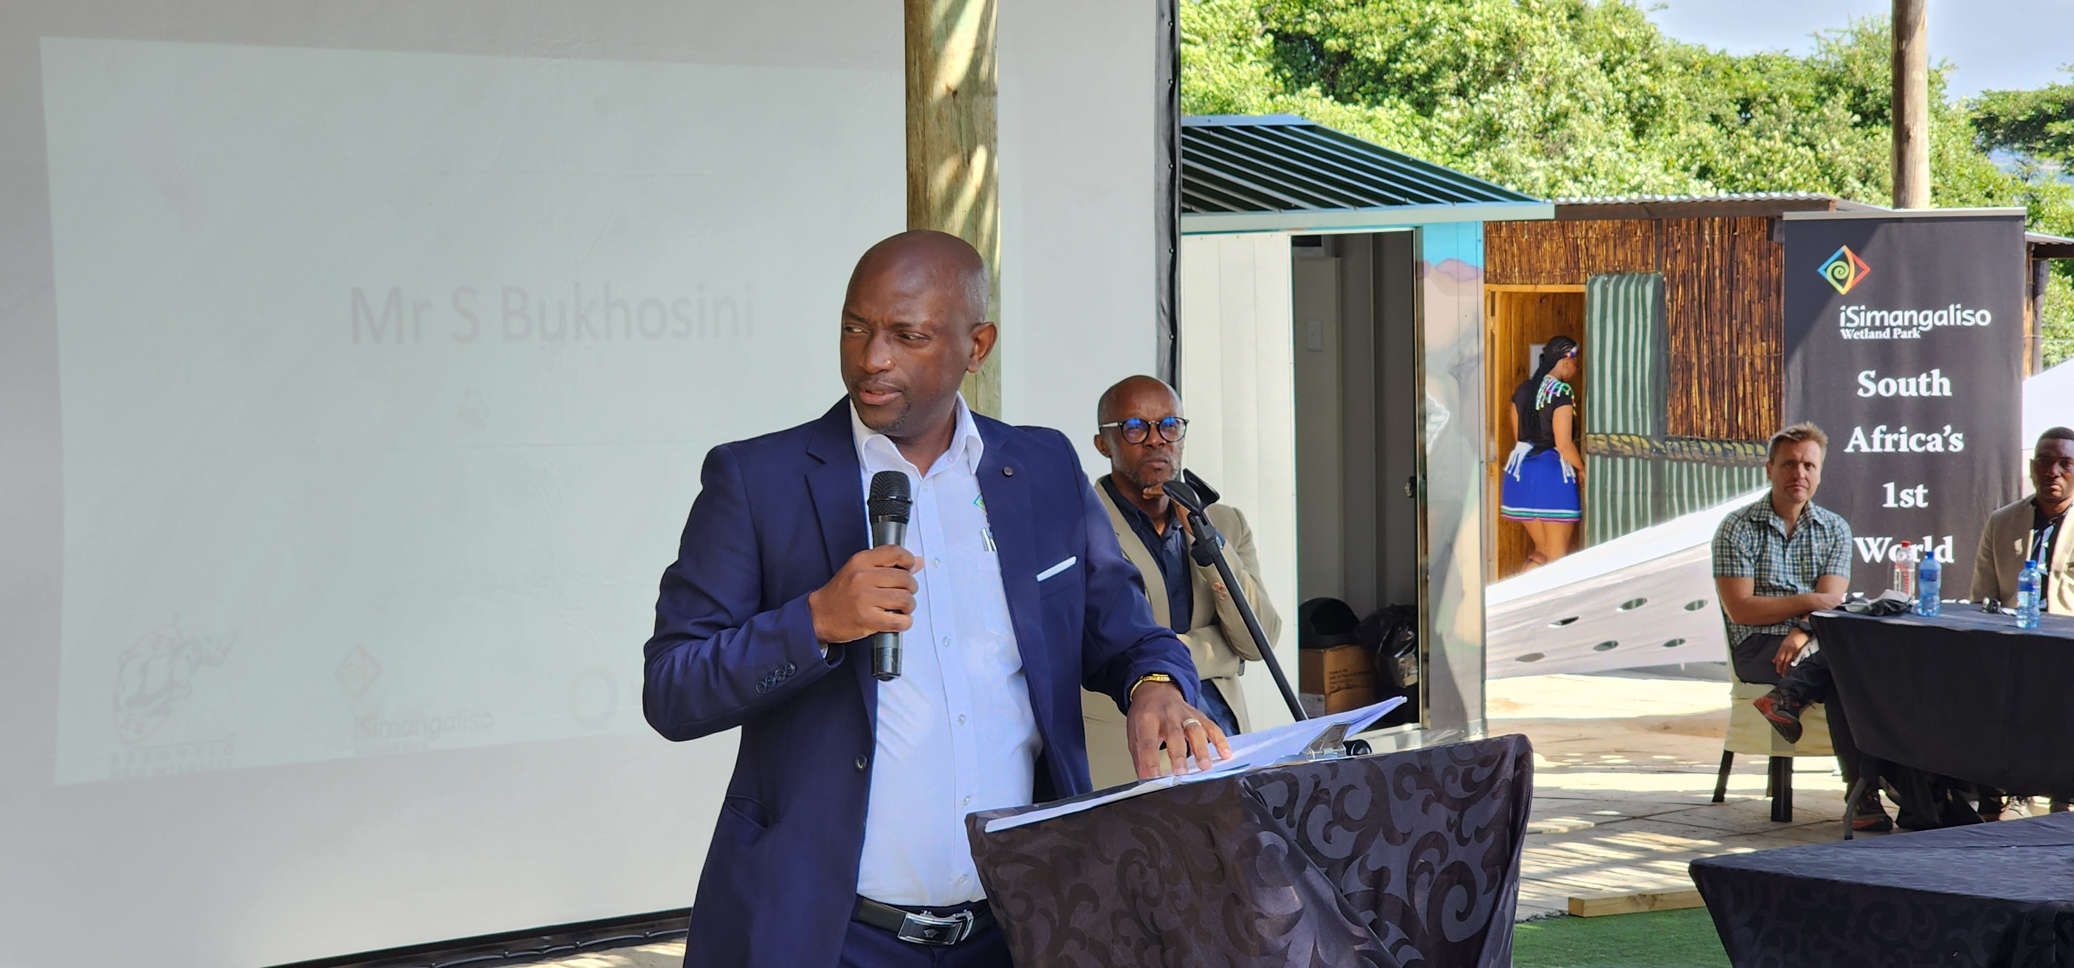
Umphathi omkhulu weSimangaliso Wetland Park uMnu. Sibusiso Bukhosini ngesikhathi ethula inkulumo mhla kuvulwa ngokusemthethweni isikhungo esizosiza kakhulu umphakathi wase eNkovukeni.

iSimangaliso Wetland Park Authority ngokubambisana ne-Wild Oceans ohlelweni olwaziwa ngokuthi yi-Oceans Alive, Ezemvelo KZN Wildlife kanye neTembe Traditional Authority bathule ngokusemthethweni isikhungo esizosiza kakhulu umphakathi waseNkovukeni esibizwa ngokuthi yi-eNkovukeni community resource hub.

Ngalesi sikhungo kuhloswe ukuthi kube isikhungo esizohlomulisa umphakathi ngokuwulekelela ezintweni ezifana nokuqwashisa umphakathi mayelana nezilwane ezihlala olwandle, ukuqeqesha abantu, ukuthuthukisa labo abasebancane emkhakheni ehlukahlukene, ngamathuba emisebenzi entsheni, ukulekelela umphakathi kwezokongiwa kwemvelo kanye namathuba atholakala kwezokuvakasha, ukuba nezinsiza (isibonelo. Umtapo wolwazi, indawo yokudlala izingane, indawo yokugcwalisa omakhalekhukhwini, uku-printer, amakhompuyutha, kanye ne-inthenethi), ukukhangisa imisebenzi yezandla kanye nokudayiswa kwayo, bese kuba ukutshengiswa kwamaPhrojekthi ahlobene nesisombululo kwezokongiwa kwemvelo kanye nokuguquguquka kwezolimo.

eNkovukeni yindawo etholakala kwingxenye eseNyakatho yePaki eKosi Bay. Lona umphakathi osasilele emuva kakhulu ezintweni eziningi. Lo mphakathi waseNkovukeni uwela ichweba uphinde uhambe ibanga elide uma uya edolobheni eManguzi ukuyokwenza izinto ezincane ezifana nokusebenzisa ikhompuyutha ukuze kuzofakwa izicelo zomsebenzi, ukwenza umsebenzi wesikole kanye nokukhipha amadokhumenti noma amakhophi. Njengoba lesi sikhungo sesisebenza, sekuzoba umlando emphakathini ukukhipha amashumi ayisithupha amarandi ukuthi uye edolobheni eManguzi uyosebenzisa ikhompuyutha ngoba lesi sikhungo sinakho konke lokhu ababekuhambela ibanga elide.

Umphathi omkhulu weSimangaliso Wetland Park uMnu. Sibusiso Bukhosini wabalula ukuthi uyaziqhenya ngobudlelwano iSimangaliso esibakhe ne-Wild Oceans, Ezemvelo KZN Wildlife kanye ne Tembe Traditional Council. Kuwumsebenzi weSimangaliso ukuvikela, ukugcina kanye nokwethula ubugugu boMhlaba esizukulwaneni samanje kanye nesizukulwane esilandelayo kube kuzuza imiphakathi ehlala ePaki kanye naleyo eyakhelene nePaki ngokwenza lula ezokuvakasha kanye nokuthuthukisa konke okuhlobene nezokuvakasha. Wabe esehalalisela umphakathi waseNkovukeni ngokwakhelwa lesi sikhungo. UBukhosini wabe esethi, “Ukuthuthukisa imiphakathi efana nomphakathi waseNkovukeni yikho kanye okuhloswe iSimangaliso njengoba izinhloso zeSimangaliso kuwukuthuthukisa imiphakathi esasilele emuva”.

Lesi sikhungo sikhulu ngokwanele ukuthi umphakathi ungabambela khona imihlangano kanye nokuqeqeshwa komphakathi kungenziwa khona lapha. Isikhungo saseNkovukeni singesesithathu kuzikhungo esezikhandelwe imiphakathi ehlala ePaki. Kunesikhungo esiseMabibi kanye nesiKwaDabha okuyizikhungo ezenza umsebenzi ofanayo nalo owenziwa isikhungo saseNkovukeni. Selokhu kwalaqwa ukwakhiwa kwalezi zikhungo, sekuqashwe abantu abangamakhulu amane namashumi ayisishiyagalombili nantathu, kwaqashwa abaphathi abayisishiyagalolunye, inkontilaki yaqasha abangamashumi ayisishiyagalombili nesithupha, kwahlomula amangamashumi ayisithupha nesikhombisa ngemishini yokuthunga, kwaba nabayikhulu neshumi nantantu abangama-Turtle monitors, kanye nabangaphezu kwekhulu namashumi amathathu abangama-Ocean Stewards.


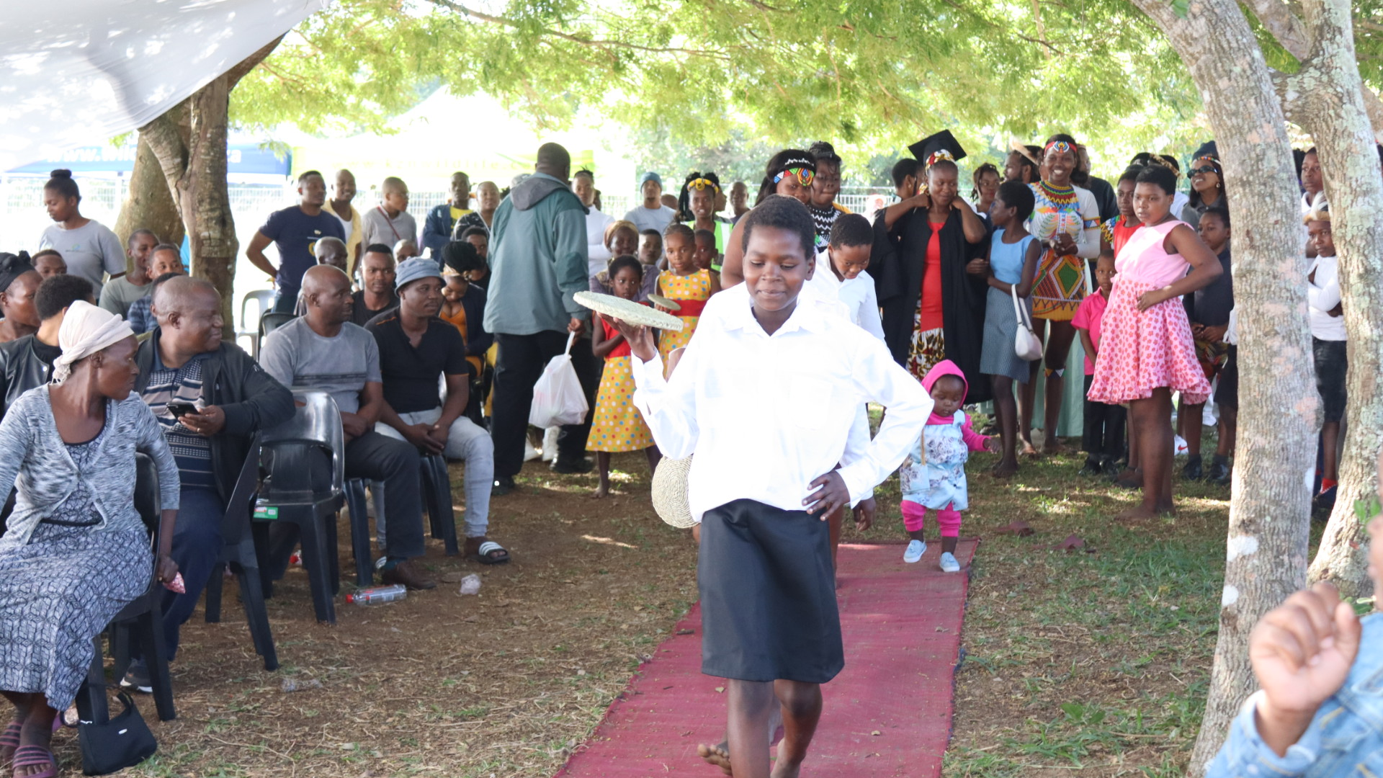

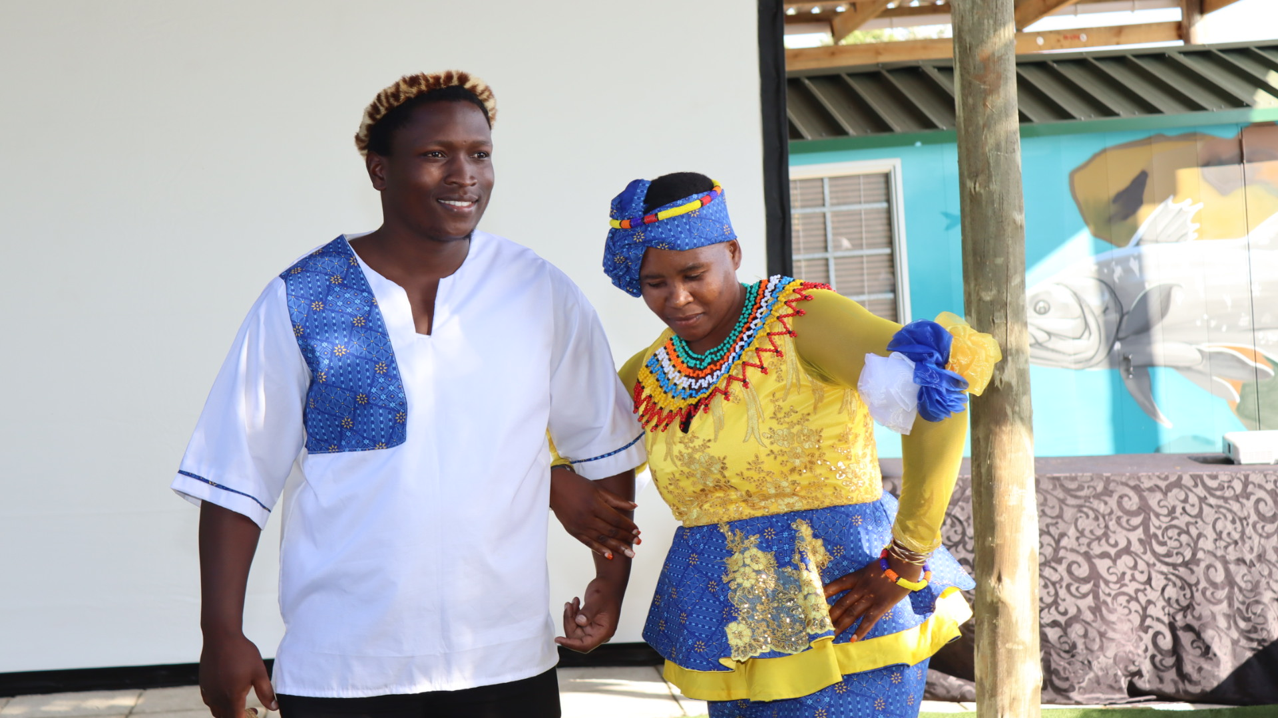
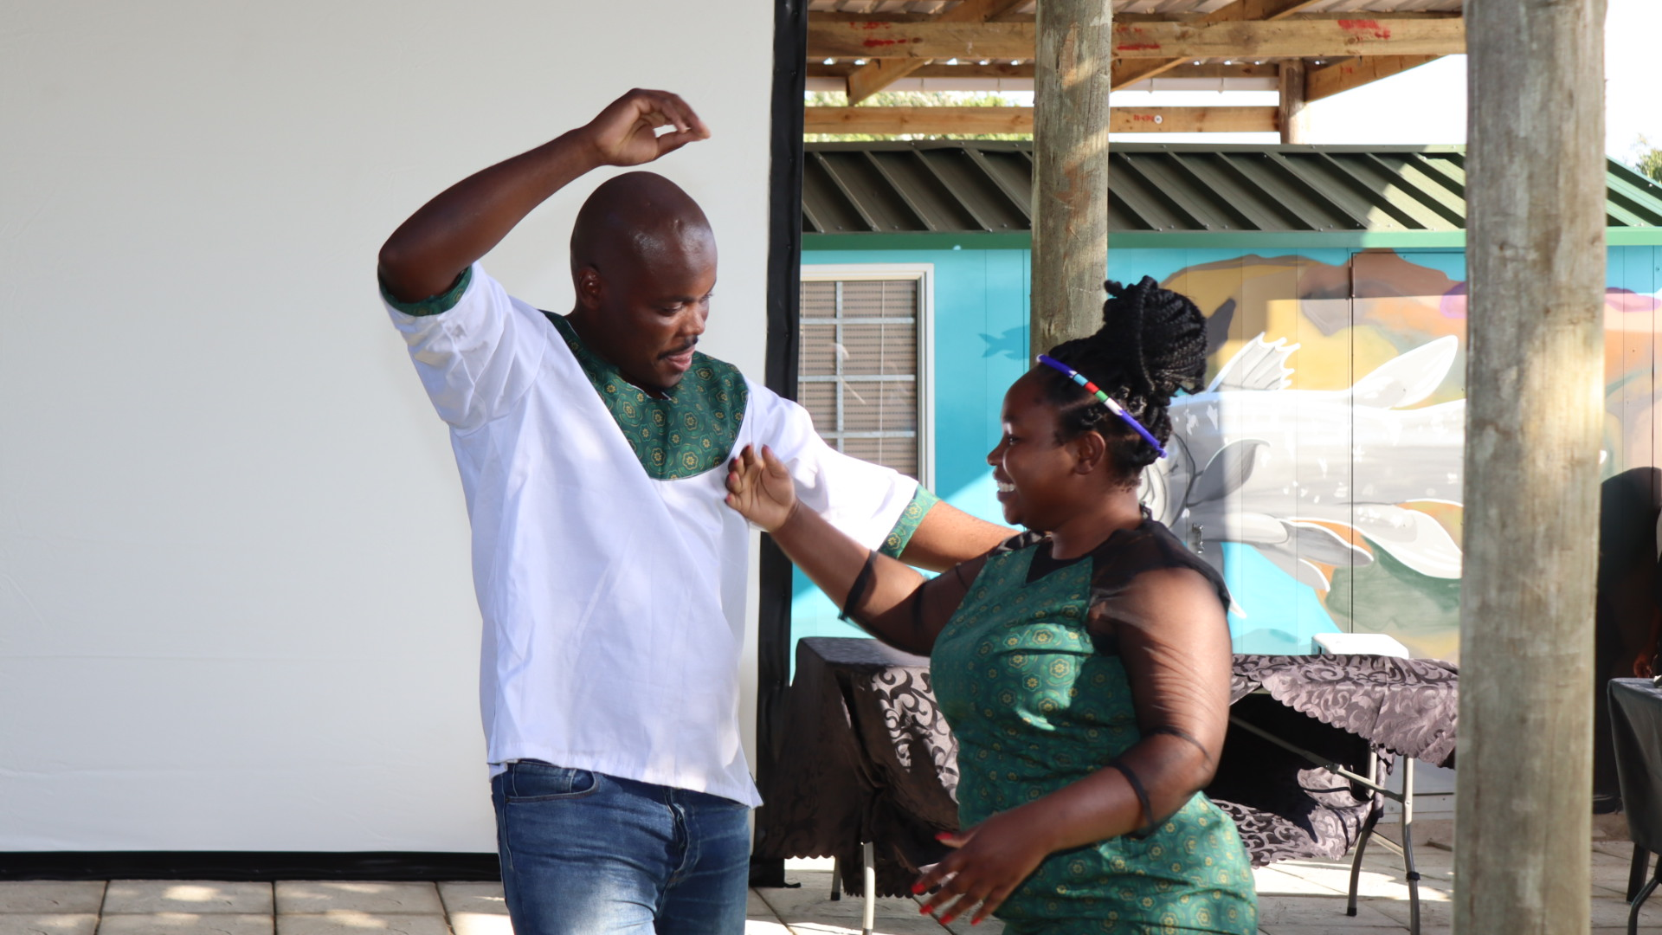
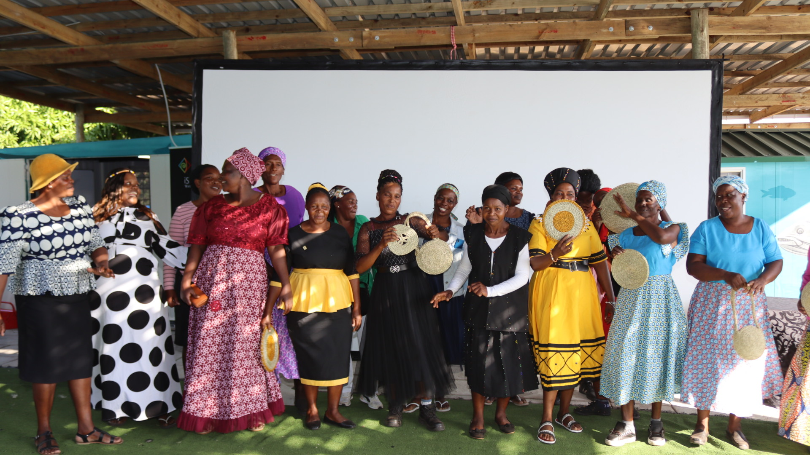
Amalungu omphakathi waseNkovukeni ekhangisa ngengqebhu ehlukahlukene ekhandwe kuso lesi sikhungo nnikwa babanikae bezi sikhungo.lukahlukene ekhandwe kuso lesi sikhungoeni ehlukahlukene benze izinto eziningi kulesi sikhungo.

Isikhungo saseNkovukeni asikhethi ngokweminyaka, wonke umuntu uyafundiswa ukuthunga. Omama abathunga lapha bakhona ukwenza inzuzo bephinde besize imindeni yabo. Bathunga imifaniswano, izimpahla zokuhloba ngesintu, izembatho zokuthweswa imiyezane, kanye nezingubo zomshado. Ukwakhiwa kwalesi sikhungo kusize kakhulu ngoba kuqashwe osonkontileka bendawo futhi banikwa amakhono kulo mkhakha azobasiza ukuthi baqhubeke nokuwasebenzisa. Intsha yakulo mphakathi enye iqashwe ngokuphelele ukuba isebenze kulesi sikhungo.

Omele ubuholi bomdabu uMnu. Vusumuzi Tembe wazwakalisa ukujabula ayenakho uma ebona intuthuko emphakathini waseNkovukeni. Waveza ukuthi lesi sikhungo sizoba nomphumela omuhle emphakathini ngoba manje sebezokhona ukuthi benze izinto eziningi kulesi sikhungo. Kanti noNkosazana Makhosi Mathenjwa oyintsha yakuyo le ndawo akakwazanga ukuzibamba uma ebona le ntuthuko waveza ukuthi intsha isizofundiswa kakhulu ngokongiwa kwemvelo kanye nezilwane ezihlala olwandle.

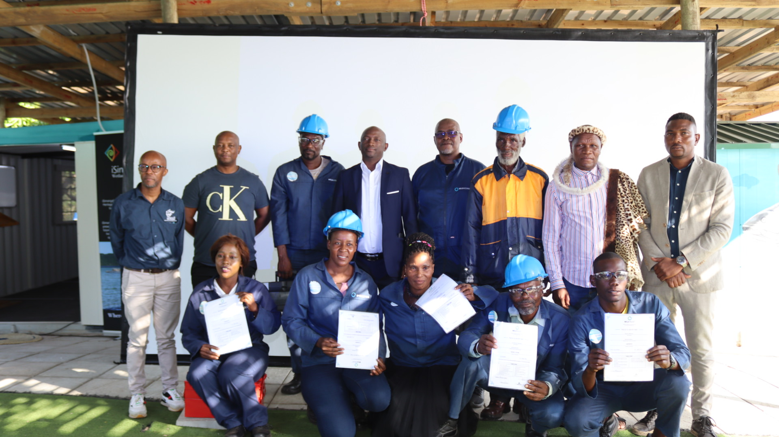
Amanye amalungu omphakathi waseNkovukeni ahlonishwe ngezitifiketi kanye namathuluzi okusebenza emikhakheni ehlukahlukene.

-Iyaphela-

Isitatimende sikhishwe iSimangaliso Wetland Park Authority
Abezindaba bengaxhumana no:
MLO: Mr Bheki Manzini
Call/Whatsap: 060 533 2082
Email: bhekimanzini@isimangaliso.com

