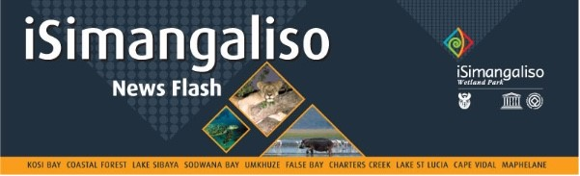

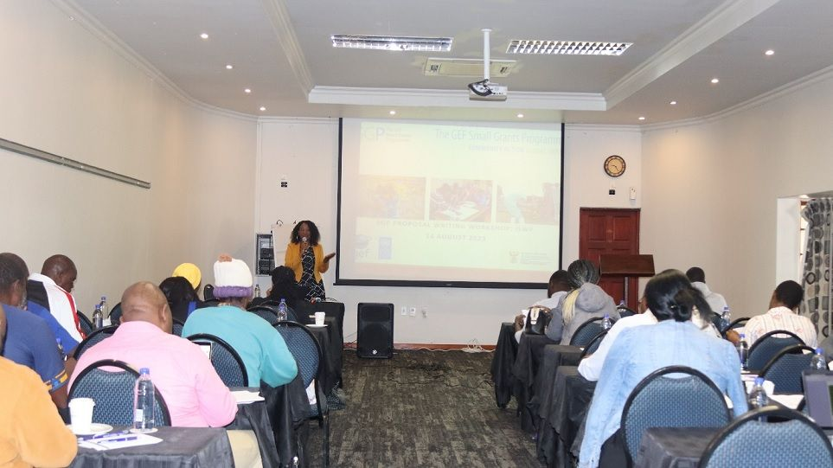**ISIMANGALISO SIHLOMISA IMIPHAKATHI NGOKUBHALWA KWEZICELO ZOXHASO**

Ithimba leSimangaliso lihlanganyele nomphakathi emhlanganweni wokufundiswa ngekhono lokubhala isicelo soxhaso. Lo mhlangano bewubanjwe mhlaka 13 kuya ku14 kuNtulikazi 2023 ngenhloso yokulekelela osomabhizinisi abasakhula ngokubhalwa kwezicelo zoxhaso olufika emalini elinganiselwa *ku-USD50,000.*

Emhlanganweni wakamuva, kube nokucobelelana ngolwazi mayelana nokuthuthukiswa komphakathi. Lokhu kuza ngemuva kokuthi ithimba *leGEF-7* liveze ithuba lokuxhasa abafuna ukwenza amaphrojekthi angeqi kusamba sika-*USD50 000.* Kube sekuthathwa isinqumo sokuthi kube nomhlangano wokufundiswa ngokubhalwa kwesicelo soxhaso lapho bekumenywe osomabhizinisi abasakhula ukuba nabo balekelele abanye mayelana nokubhalwa kwencwadi yokufakwa kwesicelo soxhaso ngaphansi kwalolu hlelo.

Ithimba leSimangaliso lidlulise isimemo kweminye iminyango ehlukene kanye nomasipala ukuba bezolekelela mayelana nokufundisa kokubhalwa kwalezi zincwadi zokucela uxhaso kanye nokuphendula imibuzo evelayo. Imiphakathi ongomakhelwane nepaki ilamukele ithuba elinikwe iSimangaliso njengoba bebephume ngothi lwabo ukuzothamela lo mhlangano wokufundiswa. Phambilini, kuke kwaba nomhlangano lapho abaholi bezinhlangano ezidinga uxhaso befike eSimangaliso ukuzokwethula izicelo abafisa ukuxhaswa ngazo.

Omasipala ababa yingxenye yalo mhlangano kwaba *yi-Big 5 Hlabisa Local Municipality, Mtubatuba Local Municipality, Jozini Local Municipality, uMhlabauyalingana Local Municipality, kanye noMhlosinga Development Agency*. Ngaphezu kokufundiswa komphakathi, lokhu kukhomba ukuzibophezela okukhona mayelana nokuthuthukiswa komphakathi ngokuhlanganyela kwezinhlaka ezahlukene, kudaleke ukugqugquzeleka kulo mhlangano kanye nempumelelo, kwananele kuyo yonke imingcele yeSimangaliso Wetland Park.

**-Iyaphela.-**

**Abezindaba bengaxhumana nokhulumela iSimangaliso Wetland Park:**

Mr Bheki Manzini

Call/Whatsap:060 533 2082

Email: bhekimanzini@isimangaliso.com