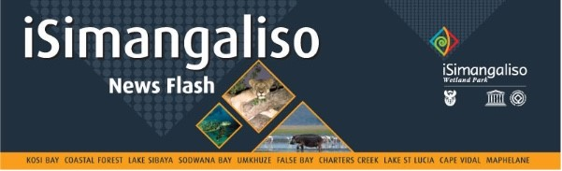

**23 July 2024**

# **iSimangaliso GEF-7 Biodiversity Stewardship Workshops yield positive results**

**INSERT THE VIDEO**

iSimangaliso Wetland Park GEF-7 together with Ezemvelo KZN Wildlife hosted the Biodiversity Stewardship Workshops within communities neighbouring iSimangaliso. The objective of these workshops was to educate community stakeholders about the importance of conserving nature, and benefits that communities can reap through biodiversity economy, foster collaboration and cooperation, support and promote compatible land-use practices in areas within and adjacent to the Biodiversity Economy projects, promote participation and upliftment of youth and women, and support the development of community-based initiatives. These workshops were also attended by The Department of Forestry, Fisheries and the Environment (DFFE) and South African National Biodiversity Institute (SANBI).

The three days workshops were attended by various stakeholders such as Traditional authorities, trusts, fishing co-operatives, NGO’s, traditional healers, and other community structures. The first workshop was attended by the traditional leadership and trust members of Makhasa, Jobe and Ngwenya communities at Hluhluwe Community Hall. The second workshop was attended by Mabasa and Tembe traditional authorities at Mabasa traditional tribal court and the last workshop was attended by Nibela traditional authorities held at Nibela traditional tribal court.

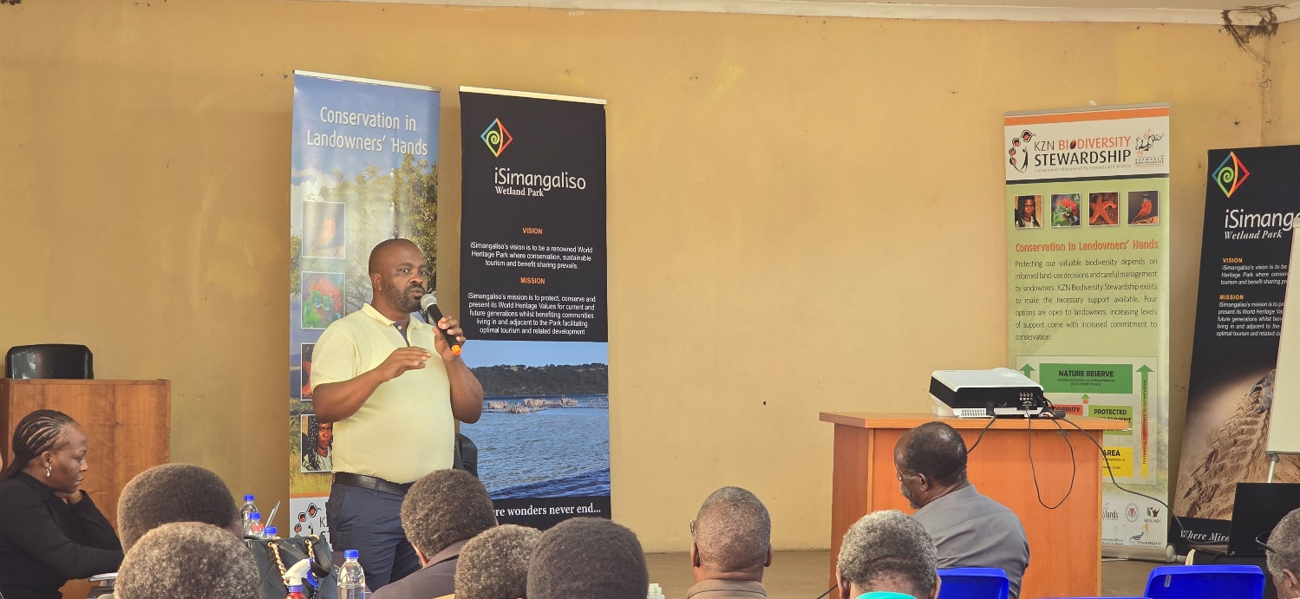

The Biodiversity Economy of South Africa includes the businesses and economic activities that either depend on biodiversity for their core business or that contribute to the conservation of biodiversity through their activities which are business related to bioprospecting, ecotourism, wildlife economy, and conservation of nature. iSimangaliso Wetland Park Senior Project Manager Mr Sibusiso Zondi highlighted the objectives of the biodiversity stewardship programme as he was elucidating the purpose of these workshops. “Through this initiative, iSimangaliso and Ezemvelo is not trying to take community owned land. This programme will assist communities to start reaping benefits from their land by creating businesses which will create employment for community members, and benefit communities through bioprospecting, or ecotourism or wildlife economy, or hunting.

These workshops were facilitated by Ezemvelo KZN Wildlife as they are the custodians of stewardship programmes in the Province of KwaZulu Natal. The Ms Tembisa Jordaan presented to the communities the process and procedure of having land declared as a biodiversity stewardship site. This included the site identification and initiation of landowners interactions, biodiversity assessment and review of the property, contract negotiations and draft management plan with landowner, Ezemvelo KZN wildlife internal approvals, cost analysis, submissions and formal proclamation for MEC’s endorsement, and support provided to protected areas.

Mr Thokozani Mlambo who is a Member of Makhasa Trust and Makhasa traditional leader expressed his gratitude and what he has learned from the workshop. “I appreciate iSimangaliso and all its partners for initiating such programmes. As the Makhasa Community, we have a land that has been declared as a nature conservation area and iSimangaliso is assisting us with some of the things through the GEF-7. I have learnt a lot from this workshop and I hope it wont be the last one. I request that you provide such trainings to communities so that we are clear about the processes, challenges to expect and benefits that we can reap through this initiative”, said Mr Mlambo.

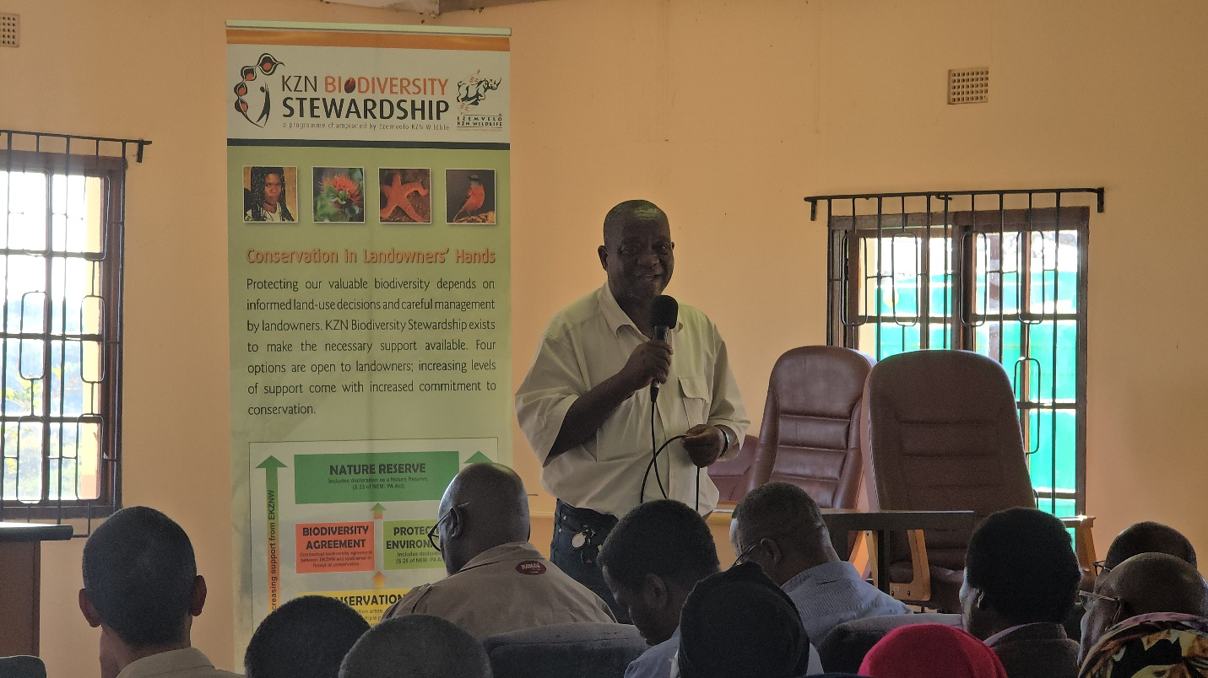

Representative of Mabasa traditional council Mr Eric Nxumalo also appreciated the efforts made by the government structures to ensure these workshops became success. “This was a very informative workshop and I believe it will benefit our community. I would like to thank all those who participated and raised relevant questions with an aim of seeking clarity before we as the community take the decision. I sincerely request that iSimangaliso and Ezemvelo schedule another workshop which will focus on Mabasa community”, said Mr Eric Nxumalo.

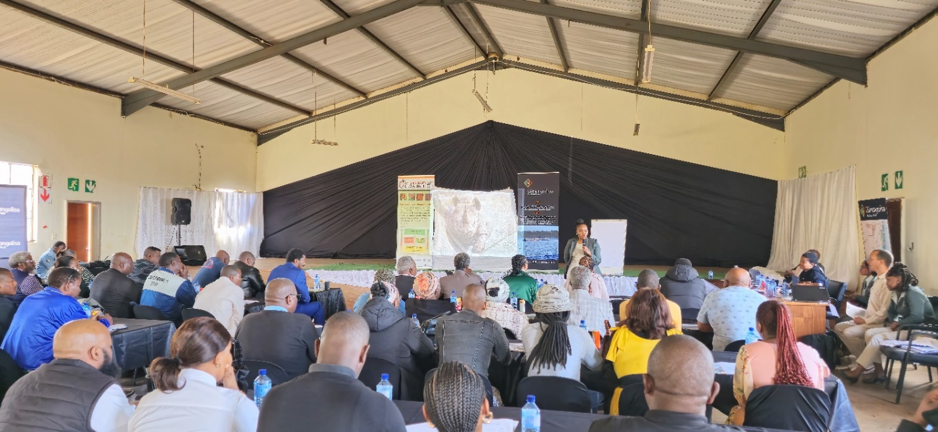

Nibela Prime Minister Mr MH Ngubane appreciated the continued presence of iSimangaliso in Nibela community. “recently, iSimangaliso employed youth from our communities through the Groen Sebenza programme and the EPWP programme, that really assisted many disadvantaged families. I plead with iSimangaliso to keep creating job opportunities and businesses that will develop Nibela and fight against poverty”, said the Prime Minister Mr MH Ngubane.

iSimangaliso GEF-7 is in the process of assisting three communities (Makhasa, Mabasa and Nibela) to be declared a Community Conservation Areas (CCA) and be listed under stewardship sites. The project of Mabasa Community Conservatory is aimed at supporting the community stewardship. The scope of work for Mabasa Community Conservation includes erection of the parameter fence, access gate and the security kiosk, Facilitate game donation, and Capacity Building for community own initiatives. The scope of work for Makhasa Community Conservation includes social support and Community Stewardship, Construct conference and ablution facilities, kitchen, and swimming pool, Facilitate game donation and capacity building for community own initiatives. The scope of work for Nibela Community Conservation includes the development community stewardship, Support Social and Community Stewardship, and capacity Building for community own initiatives.

**-End-**

**Statement issued by iSimangaliso Wetland Park Authority**

**Media enquires**

MLO: Mr Bheki Manzini

Call/Whatsap: 060 533 2082

Email: [bhekimanzini@isimangaliso.com](mailto:bhekimanzini@isimangaliso.com)