**22 kuNtulikazi 2024**

**UMHLANGANO WOKUCOBELELANA NGOLWAZI UBE NEMIPHUMELA EMIHLE**

**INSERT THE VIDEO**

Ithimba leSimangaliso Wetland Park ngokubambisana neZemvelo KZN Wildlife libe nomhlangano wokucobelelana ngolwazi kanye nemiphakathi engomakhelwane nepaki. Inhlosongqangi yale mihlangano ukufundisa imiphakathi kanye nabo bonke ababambe iqhaza eSimangaliso mayelana nokubaluleka kokongiwa kwemvelo, kanye nokufundisa ngemihlomulo etholakala ngokongiwa kwemvelo kanye nokufundisana ngokubaluleka kokusebenza ngokubambisana, ukwesekwa kanye nokukhuthaza izinqubo ezihambisanayo zokusetshenziswa komhlaba ezindaweni ezingaphakathi nezisondelene nepaki, ukukhuthaza ukubamba iqhaza kanye nokuthuthukiswa kwentsha nabesifazane kanye nokwesekwa kwezinhlelo zokuthuthukisa imiphakathi. Le mihlangano ibihanjelwe uMnyango wakwa-*DFFE,*kanye no-*SANBI.*

Lemihlangano yezinsuku ezintathu, beyithanyelwe ababambe iqhaza abahlukahlukene okufaka phakathi ubuholi bomdabu, izinhlangano zabadobi, izinhlangano ezingayenzi inzuzo (*NGO’s)*, abelaphi bendabuko kanye nezinye izinhlaka zomphakathi. Umhlangano wokuqala wawuthanyelwe ubuholi bomdabu kanye namalunga eTrust baseMakhasa, kwaJobe kanye nakwaNgwenya, ubanjelwe eHholo lomphakathi eliseHluhluwe. Umhlangano wesibili wawuthanyelwe ubuholi bakwaMabasa kanye nobakwaTembe kanti umhlangano wokugcina wawukwaNibela enkantolo yenkosi.

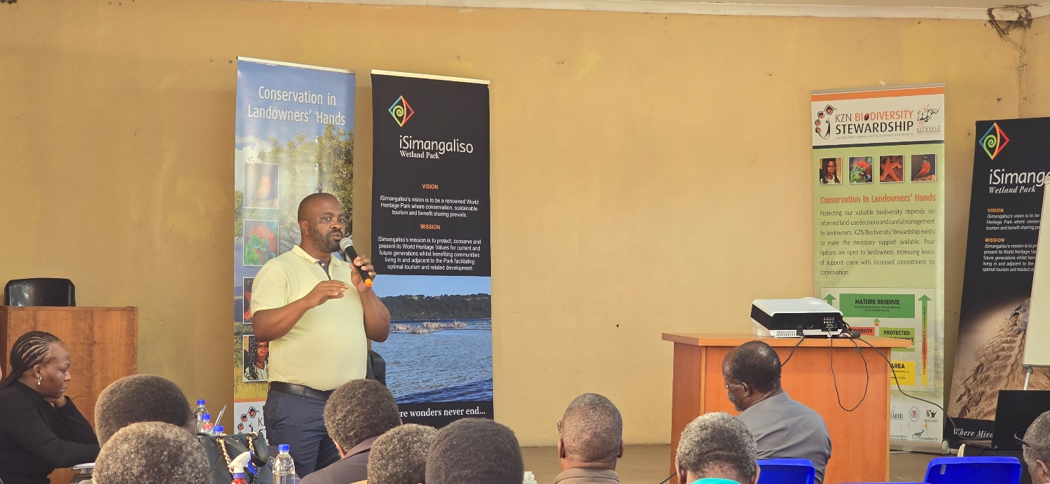

Lo mnotho wezemvelo okukhulunywa ngawo lapha eNingizimu Afrika uhlanganisa ezamabhizinisi kanye nemisebenzi yezomnotho encike kakhulu kulolu hlobo lokwakha umnotho okanye ukuba nesandla ekongiweni kwemvelo ngokuthi kube nezindlela ezahlukene eziyamanisa lolu hlobo lokuhweba ngokuphica, ezokuvakasha, ezemvelo kanye nokuvikelwa kwayo. OnguMlawuli wama-Projekithi eSimangaliso (*iSimangaliso Wetland Park Senior Project Manager*) uMnu.Sibusiso Zondi wakhela phezulu inhlosongqangi ngenkathi echaza kabanzi ngenhloso yale mihlangano yokufundisana. “Ngalolu hlelo, iSimangaliso kanye neZemvelo asizami ukuthi sithathe imihlaba wemiphakathi. Lolu hlelo luzosiza umphakathi ukuthi kube khona izithelo ozitholayo ngokusungula amabhizinisi azodala amathuba emisebenzi emiphakathini kusetshenziswa imithi eyahlukene, ezokuvakasha kanye ukuzingela”.

Abezemvelo yibona ababeqhuba lemihlangano njengoba kuyibo abanikwa igunya lokusingatha uhlelo lwe-*stewardship* ngaphansi kwesifundazwe saKwaZulu Natali. UNksz Tembisa Jordaan ovela ngaphansi kweZemvelo waba nesethulo mayelana nohlelo olulandelwayo kanye nenqubo mngomo ukuze indawo ingene ngaphansi kohlu lwezindawo zokongiwa kwemvelo. Lokhu kufaka phakathi ukuthi kuqale kwazeke kuphinde kuxhunywane nomnikazi waleyo ndawo, kubhekisiswe leyo ndawo, kuxoxiswane mayelana nokuba nesivumelwano nomnikazi wayo, kube nokuqinisekisa kwabeZemvelo KZN Wildlife, kubhekwe inani bese kuthunyelwa kuNgqongqoshe wesifundazwe saKwaZulu Natali ukuba akhiphe isinqumo mayelana nokuthi leyo ndawo ibe ngevikelwe.

uMnuz. Thokozani Mlambo oyilungu leMakhasa Trust kanye nobuholi bomdabu bakwaMakhasa, wazwakalisa ukujabula okukhulu mayelana nasekufundile kulo mhlangano. “Ngiyasibonga kakhulu iSimangaliso kanye nozakwabo ngokuqalisa lolu hlelo. Njengomphakathi wakwaMakhasa, sinendawo esifakwe ngaphansi kohlu lwezindawo ezivikelwe kanti futhi iSimangaliso sisilekelela kakhulu. Ngifunde okukhulu kulo mhlangano futhi nginethemba lokuthi akukhona okokugcina ngifunda. Ngicela ukuthi umphakathi unikwe loluhlobo loqeqesho ukuze sizoba nolwazi ngalolu hlelo, izingqinamba esingazilindela kanye nemihlomulo ekhona kulolu hlelo”, kusho uMnuz. Mlambo.

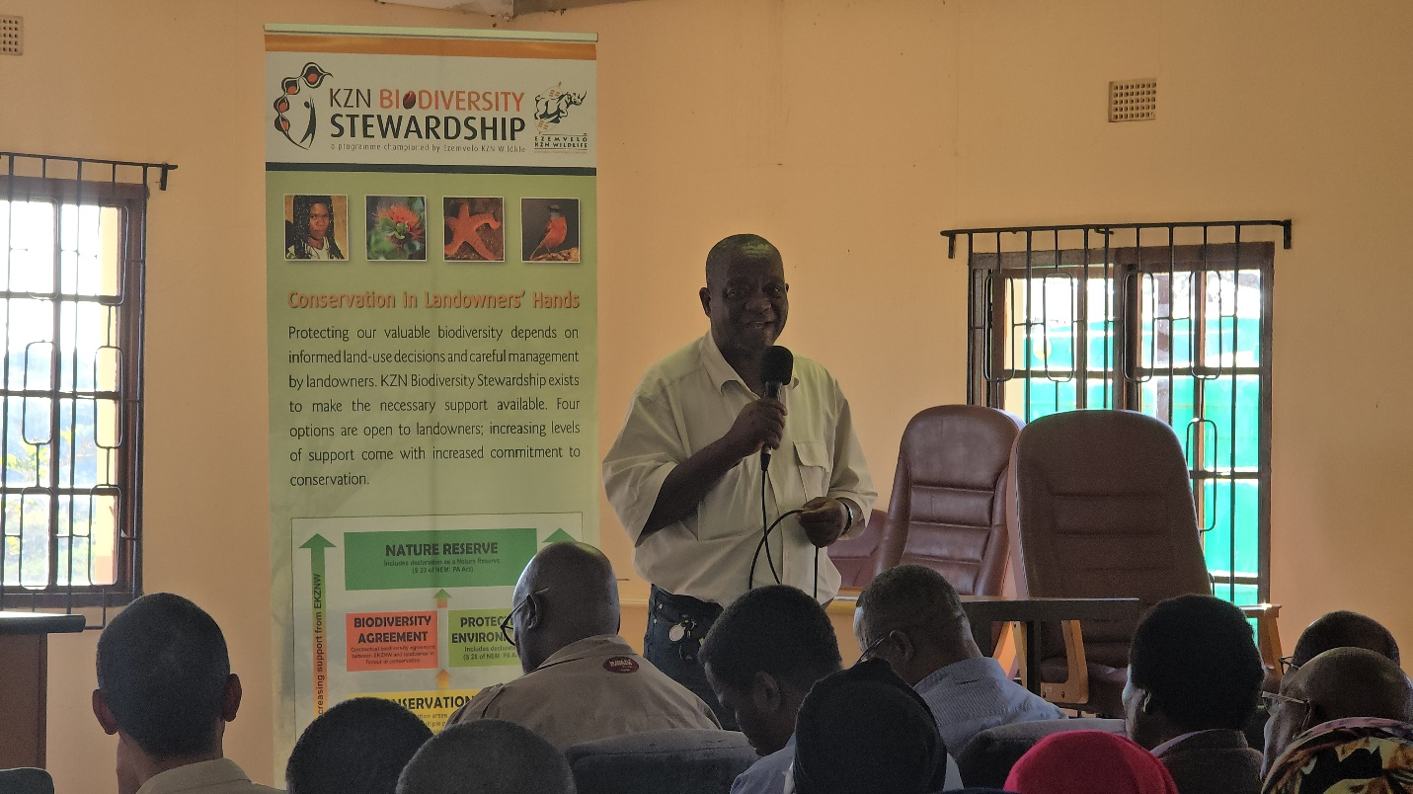

Omele ubuholi bakwaMabasa uMnuz. Eric Nxumalo naye wabonga ukuzikhandla kwezinhlaka zikahulumeni ukuqinisekisa ukuthi imihlango enjena iba impumelelo. “Lona kube umhlangano omqoka kakhulu nengithemba ukuthi uzohlomulisa kakhulu ngolwazi umphakathi. Ngithanda ukubonga bonke ababambe iqhaza kanye nalabo abaveze imibuzo emqoka ngenhloso yokuthola ukuchazelwa kahle ngaphambi kokuthi umphakathi uthathe isinqumo. Ngiyazithoba Futhi ngiyacela iSimangaliso kanye neZemvelo ukuba baphinde basihlelele omunye umhlangano ozobhekisisa kumphakathi wakwaMabasa”, kusho uMnuz. Eric Nxumalo.

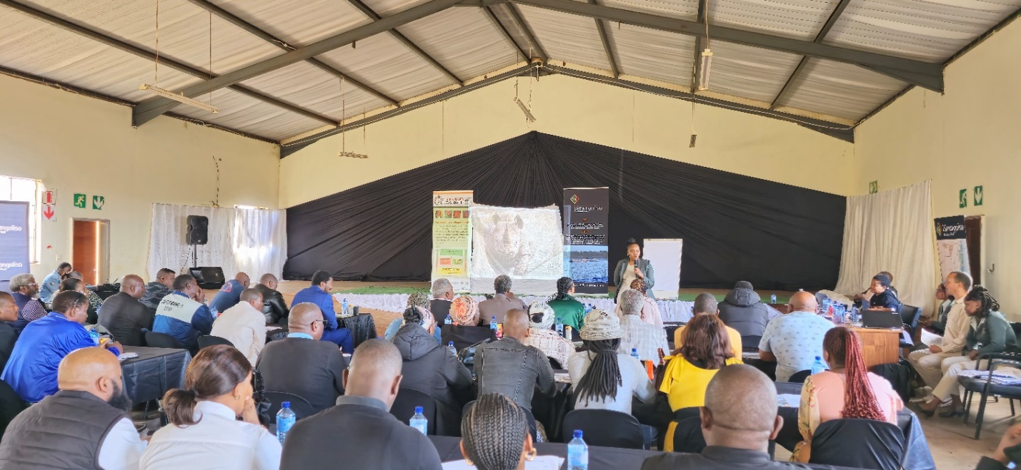

UNdunankulu wesizwe sakwaNibela uMnuz. M.H. Ngubane wabonga kakhulu ukuthi iSimangaliso silokhu siqhubeka sibonakala emphakathini wakwaNibela, “Muva nje, iSimangaliso sisanda kuqasha intsha ngaphansi kohlelo lwe-*Groen Sebenza* kanye ne*-EPWP*, lokho kusiza kakhulu ikakhulukazi emindenini ehlwempu. Ngiyacela ukuthi iSimangaliso siqhubeke nokudala amathuba emisebenzi kanye namabhizinisi ukuze kuzothuthukiswa umphakathi wakwaNibela kuxoshwe ikati eziko”, kusho uNdunankulu uMnuz. M.H. Ngubane.

Ithimba leSimangaliso GEF-7 lisohlelweni lokulekelela imiphakathi emithathu (owakwaMakhasa, Mabasa kanye nowakwaNibela) ukuthi kube nezindawo ezingena ngaphansi kohlu lwezindawo ezivikelwe. Le phrojekhthi yakwa Mbasa ihlose ukuxhasa umphakathi. Kulomsebenzi kufaka phakathi ukuthi kufakwe ufefe lokubiya, igede kanye nendawo yonogada, ukulekelela ngokunikelwa kwezilwane, kanye nezinhlelo ezonye zokuthuthukisa imiphakathi. Ukubheka ukuthi kunikelwa kanjani ekwenzeni lo msebenzi, kanye nokuqeqesha umphakathi. Ucwaningo lwendawo yomphakathi waseMakhasa lufaka Phakathi ukulekelelwa ukuqedela uhlelo lokufaka indawo yabo ngaphansi kohlu lwezindawo ezivikelwe, ukwakhelwa ihholo lemihlangano kanye nezindlu zangasese, ikhishi, idamu lokubhukuda, ukulekelelwa ngokunikelelwa ngemfuyo, kanye noqeqesho ngezinto ezahlukene. Ucwaningo ngendawo yomphakathi wakwaNibela luveza ukuthi kumele balekelelwe ukufaka lendawo ohlwini lwezindawo ezivikelwe, ukulekelelwa ngoqeqesho lwezinto ezahlukene kanye nokuthuthukisa amabhizinisi amancane.

**-Iyaphela-**

**Isitatimende sikhishwe iSimangaliso Wetland Park Authority**

**Abezindaba bengaxhumana no:**

MLO: Mr Bheki Manzini

Call/Whatsap: 060 533 2082

Email: bhekimanzini@isimangaliso.com