**01 October 2024**

**iSIMANGALISO WECOMES THE TOURISM MONTH**

**Insert the attached video**

iSimangaliso Wetland Park as a renowned tourist destination welcomes the South African Tourism month which is celebrated at spring time in September annually. South Africa celebrates Tourism month to promote domestic travel, showcase the country's diverse tourism offerings, and highlight the sector's significant contribution to the economy of the country.

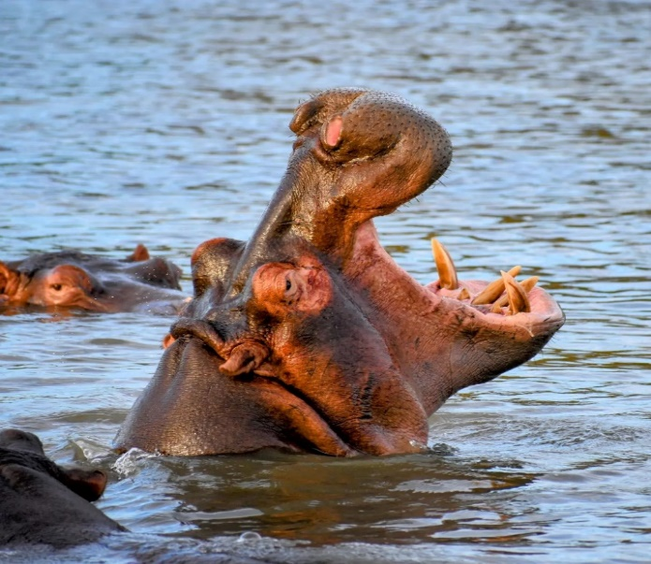Tourism month marks the approach of a jovial season on the South African calendar. Tourism sector offers a number of great opportunities. It creates jobs which contribute to revenue generation and enables people to make a living out of tourism businesses. Tourism strengthens local economy and helps to reduce poverty and inequality in the local district. It enables local people to pursue business ideas that were impossible before the introduction of tourism sector. Travelling and tourism contributes about 8.6% to South African economy and provide about 9.2% of employment in the country.

iSimangaliso has a symphony of biodiversity, graced by the presence of big seven and harmonious blend of diverse ecosystem. A place of peace and tranquillity, unique global values and superlative natural beauty. The Park creates a number of job opportunities through conservation and eco-tourism which benefits local communities. iSimangaliso’s mission is to benefit communities living in and adjacent to the park by facilitating optimal tourism and related development. “Conservation and Tourism have a huge potential to create sustainable job opportunities that can help to change the livelihoods of our neighboring communities. As the management of the park we are implementing our mission into action,” said by Mr. Bukhosini, CEO of iSimangaliso Wetland Park.

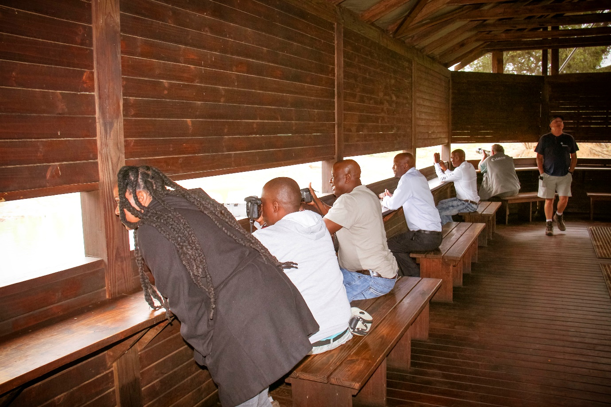

Local communities benefit from the commercialization strategy implemented by iSimangaliso. The tourism sector creates job opportunities which address issues of poverty, unemployment and inequality.The Department of Tourism recently made a media report that South Africa has ranked the highest in the African region in the 2024 Travel and Tourism Development Index (TTDI) by the World Economic Forum. The Travel & Tourism Development Index (TTDI) 2024 is the second edition of an index by the World Economic Forum. In the recent report, South Africa was ranked 55th among 119 countries and emerged as the leading country in the rankings for the African continent.

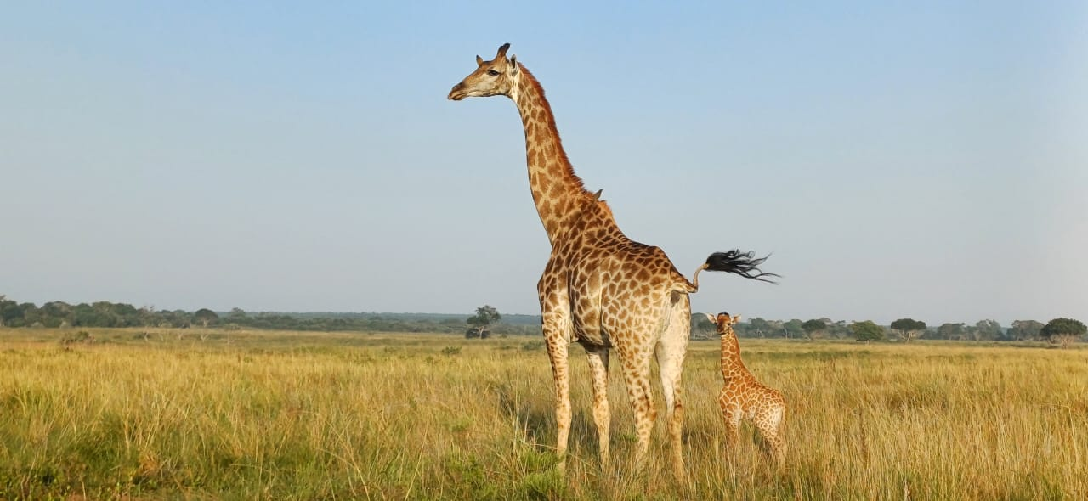

The TTDI findings revealed that South Africa is home to the largest Travel and Tourism Economy in Africa. iSimangaliso is proud to be an active drawcard that helps to grow this important sector. Visitors can enjoy the ten jewels that make up iSimangaliso Wetland Park where they remain spoilt for choice on things to see and do. Attractions include spectacular dune and mountain ranges, and diverse flora and fauna, including Wild dog, Giraffe, Black and White Rhino, Elephants, Buffalo and more than 3,000 plant types. The warm Indian Ocean supports a myriad of marine mammal species, including Humpback Whales, Bottlenose Dolphins, Humpback Dolphins and Spinner Dolphins, Sea Turtles. Access to the Southern-most coral reefs in Africa!

Visit iSimangaliso Wetland Park and have a wonderful experience of the place where miracles and wonders never ends.

-End-

**Statement issued by iSimangaliso Wetland Park Authority**

**Media enquires**

MLO: Mr Bheki Manzini

Call/Whatsap: 060 533 2082

Email: bhekimanzini@isimangaliso.com