**iSIMANGALISO SAMUKELA INYANGA YEZOKUVAKASHA**

Inyanga yezokuvakasha yandulela ukuthi sesifikile isikhathi senjabulo eNingizimu Afrika. Umkhakha wezokuvakasha unamathuba ayindathane kubantu, udala amathuba emisebenzi amaningi alekelela kakhulu ekutheni kukhandeke imali ukuze abantu bezokwazi ukuziphilisa ngamabhizinisi amayelana nezokuvakasha.

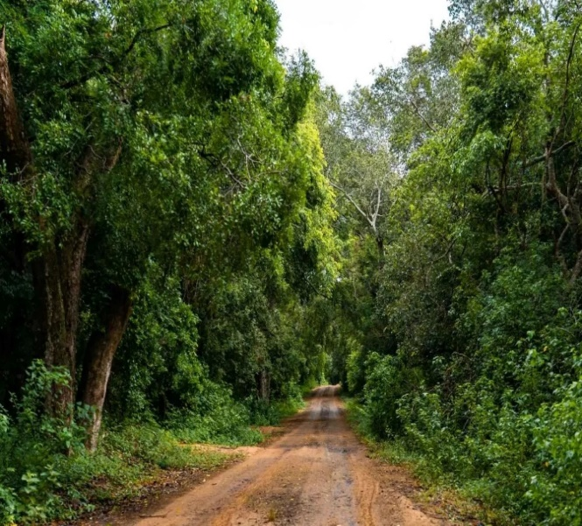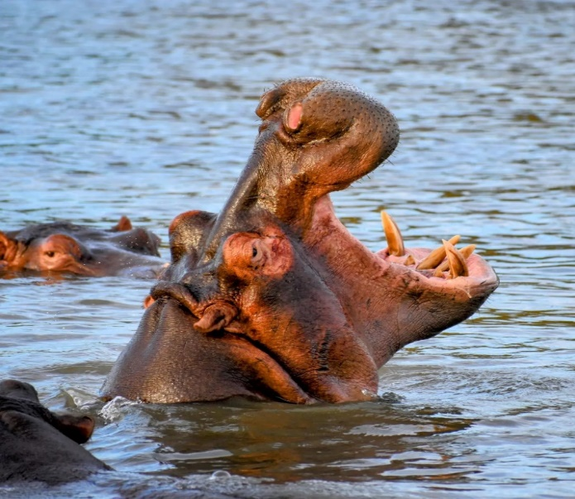iSimangaliso Wetland Park njengoba sazeka ngokuba indawo edumile kwezokuvakasha lapha eNingizimu Afrika, samukela inyanga yezokuvakasha ebungazwa ngenyanga kaMandulo minyaka yonke. iNingizimu Afrika ibungaza le nyanga ukuze ikhangise ezokuvakasha ngaphakathi, ibonise ezokuvasha ezahlukahlukene ezitholakala lapha kanye nokuveza iqhaza elibalulekile elibanjwa ezokuvakasha emnothweni wezwe.

Umkhakha wezokuvakasha uneqhaza elikhulu ekuqiniseni umnotho kanye nokuzama ukunciphisa ububha nokungalingani. emiphakathini. Lo mkhakha uvumela abantu ukuba beqhube amabhizinisi obekungelula ukuthi eqhutshwe ngaphambi kokuba kube nalo mkhakha wezokuvakasha. Ezokuvakasha zona zifaka amaphesenti alinganiselwa ku-8.6 kumnotho wezwe lapha eNingizimu Afrika uphinde udale amathuba emisebenzi alinganiselwa kumaphesenti angu-9.2.

iSimangaliso sona siyikhaya lemvelo enhlobonhlobo, kuhlotshwe ngezilwane eziheha kakhulu abavakashi kanye nenhlanganisela yemvelo ehlukahlukene. Indawo enokuthula, nobuhle bemvelo obuhlukile obukushiya ungawuvali umlomo. iSimangaliso sesidale amathuba emisebenzi amaningi kakhulu ahlomulisa imiphakathi ngawo lo mkhakha wezokuvakasha kanye nokuvikelwa kwemvelo. iSimangaliso siphathiswe umsebenzi wokuhlomulisa imiphakathi eyakhelene nePaki ngokuthi kuthukiswe ezokuvakasha ukuze kuzozuza imiphakathi. “Ezokongiwa kwemvelo kanye nezokuvakasha zinamandla amakhulu ukudala amathuba emisebenzi angalekelela ukuthi kushintshe izimpilo zabantu abasuka emiphakathini engomakhelwane. Njengobuholi bePaki senza lokhu okuwumsebenzi esiphathiswe wona ukuthi kubonakale kwenzeka,” kusho uMnuz. Bukhosini, umphathi omkhulu weSimangaliso Wetland Park.

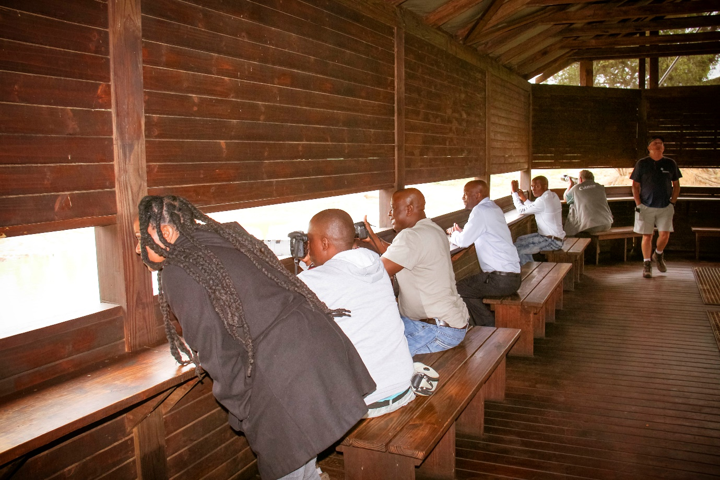

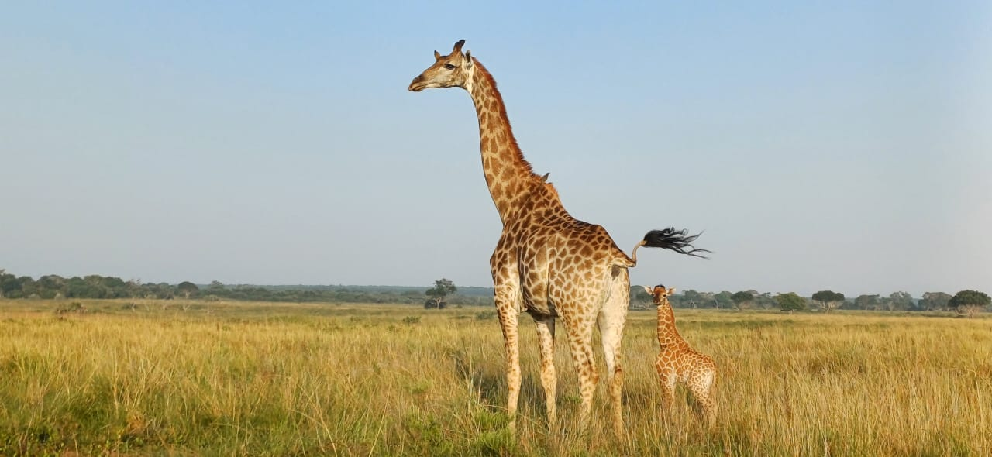Imiphakathi izohlomula kulolu hlelo lokuhweba oluqaliswa iSimangaliso, umkhakha wezokuvakasha udala amathuba amaningi asiza ukuthi kulwiswane nendlala edlangile emiphakathini, ukuntuleka kwamathuba emisebenzi kanye nokungalingani. UMnyango wezokuvakasha kamuva nje usanda kukhipha umbiko oveza ukuthi iNingizimu Afrika ihamba phambili njengendawo evakashelwa kakhulu kuleli zwekazi lase Afrika kulo nyaka ka-2024. Izibalo ziveza ukuthi *i-Travel & Tourism Development Index (TTDI)* kulo nyaka ka-2024 ilele isibili ngokomnotho womhlaba wonke jikelele. Phambilini, iNingizimu Afrika yayikeliswe kunombolo 55 emazweni angu-119 kwahamab isikhathi yathuthuka njengoba manje seyihamba phambili kuleli zwekazi laseAfrika.

Iziphumo ziveza ukuthi iNingizimu Afrika iyikhaya lezokuvakasha elihanjelwa kakhulu futhi elinonotho omkhulu. iSimangaliso siyaziqhenya kakhulu ukuba neqhaza ekudonseni abavakashi okuwukuthi lokho kusiza ukuthi kukhule umkhakha wezokuvakasha. Abavakashi bengajabulela izindawo ezilishumi eziligugu eSimangaliso ezenza ukuthi umvakashi ekhethe ukuthi ufuna ukwenza ini futhi kuphi. Kulezi zindawo zokuvakashelwa kukhona okunhlobonhlobo okufaka phakathi izindunduma ezinhle ezigudle ulwandle, izihlahla nezilwane ezahlukene okufaka phakathi amaNkentshane, iziNdlulamithi, oBhejane abamnyama nabamhlophe, iziNdlovu, iziNyathi nokunye okuningi. Kunolwandle olufudumele oluyikhaya lezilwane ezihlala emanzini okufaka phakathi iMikhome, amaDolifini, iziMfudu kanye nokunye okuningi okutholakala olwandle.

Ukuphepha kwabavakashi kuyinto ebhekwe kakhulu ukuba iqinisekiswe ukuze abavakashi bezoba nesikhathi sentokozo kakhulu ngokuvakashela iSimangaliso Wetland Park okuyindawo lapho ubuhle bemvelo buyisimanga esikushiya ungawuvali umlomo.

**-Iyaphela.-**

**Abezindaba bengaxhumana nokhulumela iSimangaliso Wetland Park:**

Mr Bheki Manzini

Call/Whatsap:060 533 2082

Email: bhekimanzini@isimangaliso.com