

**02 FEBRUARY 2025**

**FOR IMMEDIATE RELEASE**

**iSIMANGALISO WETLAND PARK CELEBRATES WORLD WETLAND DAY**

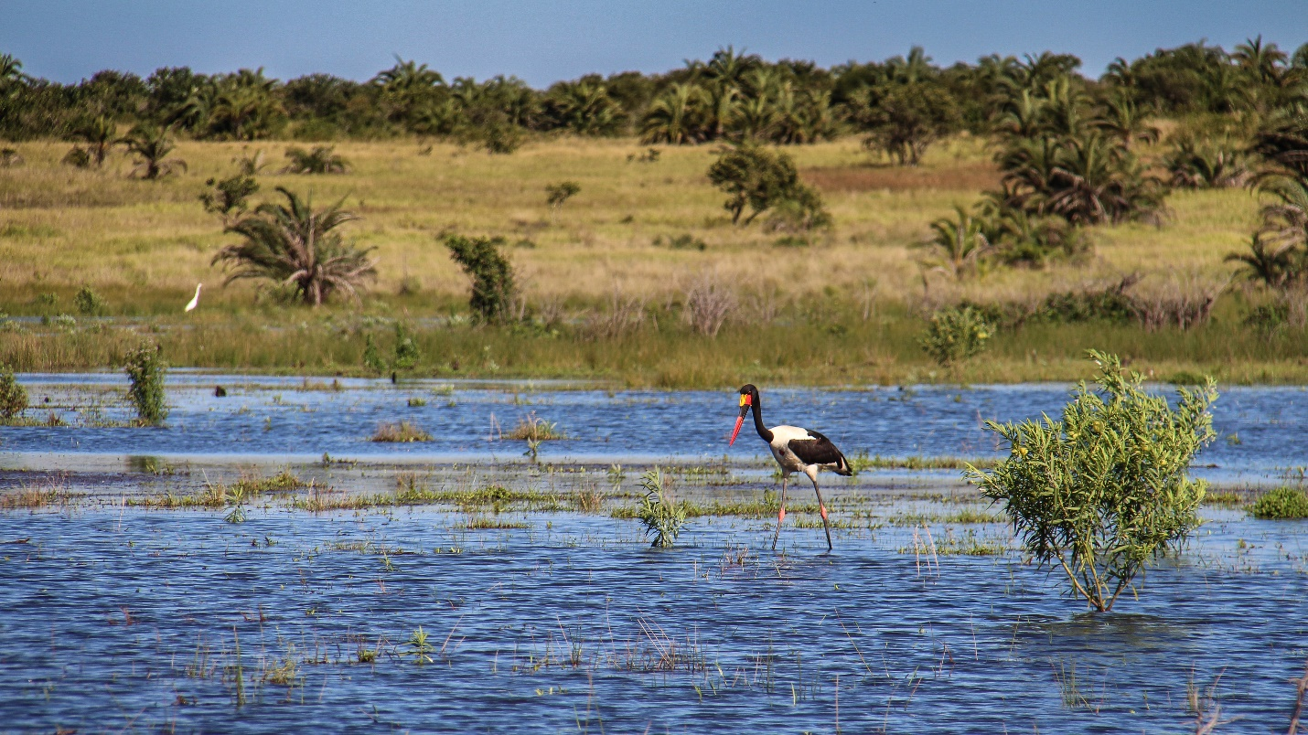

iSimangaliso Wetland Park is excited to celebrate World Wetlands Day, which is globally observed on the 2nd of February, annually. As an internationally acclaimed entity, Park Authority welcomes the 2025 RAMSAR Convention wetlands theme, which is, ‘’Protecting Wetlands for our Common Future’’. The objective of this day is to raise awareness among all sections of society, about values and functions of wetlands, the utilization of their resources, and their environmental importance. This message strongly aligns with the vision that iSimangaliso CEO Mr Bukhosini, has for the Park, as evidenced by the ongoing collaboration with WildTrust to develop key messages that will promote unity in conservation, of the Park’s Marine Protected Areas (MPA).

World Wetlands Day calls on governments, organisations, and individuals to take action to protect wetlands. According to the United Nations UN/Water, freshwater wetlands include rivers, lakes, flood plains, peatlands, marshes, and swamps. Wetlands play an important role in our communities, industries, and cultural heritage. They are essential ecosystems that provide freshwater, support biodiversity, and help mitigate climate change, as they act as natural shock absorbers, reducing the risk of flooding and storm surges.

Wetlands make up over 2,4% of South Africa’s total area. Due to several threats, wetlands have declined in our country, and the main reason for this, apart from climate change, is lack of protection. Only 11% of wetland ecosystem types in South Africa are well protected, with well over 70%, having no protection whatsoever. South Africa has 30 wetlands that are internationally recognised and are known as RAMSAR sites. iSimangaliso Wetland Park, has four RAMSAR sites, which amount to the largest total area of RAMSAR wetlands in South Africa. These RAMSAR sites, fall under the Park’s MPAs and they are; St Lucia Lake, Lake Sibaya, Mgobozeleni and Kosi Bay Lakes. The Kosi Bay system consists of four lakes, namely, Amanzimnyama, Nhlange, Mpungwini and Makhawulani.

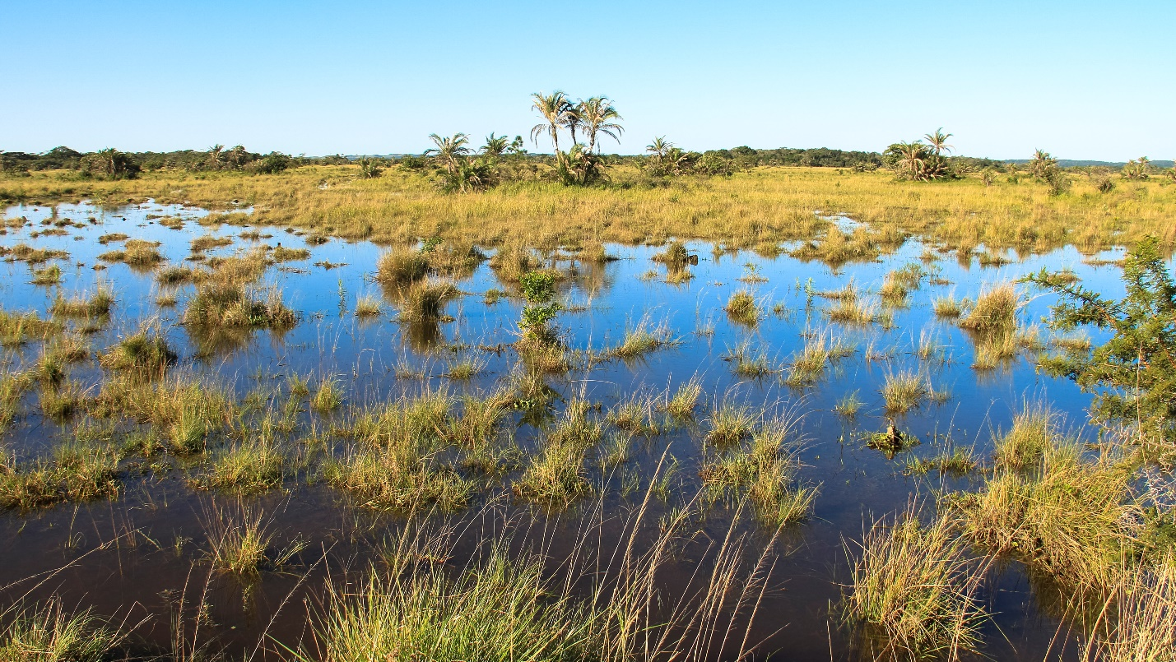

iSimangaliso Wetland Park Authority, have faced several challenges managing these RAMSAR sites, with a lot of the challenges centered around Lake Sibiya. Lake Sibaya is South Africa’s largest natural freshwater lake. It is known for its high levels of biodiversity and endemic species. The unfortunate reality is that the lakes’s water level has been decling since 2001, due to climate change and land usage. The lake’s water level is sensitive to rainfall because there are no rivers that import water into the area. Therefore, the lake only gets recharged by the rain, which has not been a reliable resource for the last couple of years. Commercial and community farming, has also contributed to a decline in water levels because of the introduction of plantation that extracts water from the lake. To counter this, Park Authority in partnership with stakeholders such as SAEON, perform monthly motoring, where rainfall and groundwater is measured through a system of boreholes and other mechanisms. Park Authority also has a Working for Wetlands project that seeks to regain ecosystem functions, within iSimangaliso Wetland Park.

There are several activities that one can participate in to celebrate World Wetlands Day. You can choose to stream a lecture that delves deep into the impact of wetlands on our ecosystem, or maybe you might want to attend a seminar about all your local wetlands and follow which, go on a nature walk with an expert, and try to identify as many plants and birds as possible. The Park offers excellent bird watching trails at our eastern shores accessed through the Bhangazi gate. At school, teachers can organise a drawing competition for learners where they are encouraged to express their vision of nature’s bounty centered around wetlands. Members of the community can organise an environmental clean-up at their local wetland to remove all pollutants.

On Monday the 3rd of February 2025, in honor of World Wetlands Day, iSimangaliso Wetland Park Authority as well as our stakeholders, will visit Khiphinkunzi Primary School which is adjacent to the Park. To create awareness around the meaning of the day, there are several activities planned for the learners, by both iSimangaliso and the school. This event is sure to enlighten young minds who are the stewards of this country’s future and as such, we look forward to planting seeds that will bear fruit for generations to come.

**-End-**

**Statement issued by iSimangaliso Wetland Park Authority**

**For Media enquires**

MLO: Mr. Bheki Manzini

Call/WhatsApp: 060 533 2082

Email: bhekimanzini@isimangaliso.com