

**iSIMANGALISO IGNITES A THRILLING LEARNING EXPERIENCE FOR UMKHANYAKUDE’S TRADITIONAL LEADERS**

***Video 1 to be inserted***

iSimangaliso Wetland Park through the GEF-7 hosted a four-day community learning exchange, at Kruger National Park and Bela Bela Communal Property Assocation (CPA) from the 10th to the 13th of February 2025. The main objective of this trip was to familiarise Traditional leaders with opportunities, that they can derive from protected areas under their care, farming and also equip them with information related to commercialisation..

This excursion provided an opportunity for Traditional leaders to travel to other geographically rural social enterprises and learn through the exchange of ideas and the sharing of common solutions. This created an opportunity for Traditional leaders to meet new people that face similar challenges and have the same interests, which led to as the Traditional leaders gaining new insights, and as we speak, a strong community network has been established and is now flourishing. This collaboration will assist communities to leverage on each other's expertise and advice, particularly in establishing successful businesses and effectively participating in the country’s economy using biodiversity stewardship programmes as a vehicle to alleviate poverty.

Traditional leaders were taken to Kruger National Park in Mpumalanga (Skukuza side), to view tourist attractions and hear some of the success storiesabout business commercialisation developments at Kruger Nation Park. Traditional leaders couldn’t believe their eyes, when they were taken to Kruger Shalati which is also known as “The Train on the Bridge”. This is the historical Skukuza train which is permanently stationed on the historically rich Selati Bridge above the Sabie River and now serves as a luxury hotel with a restaurant, bar and accommodation area.

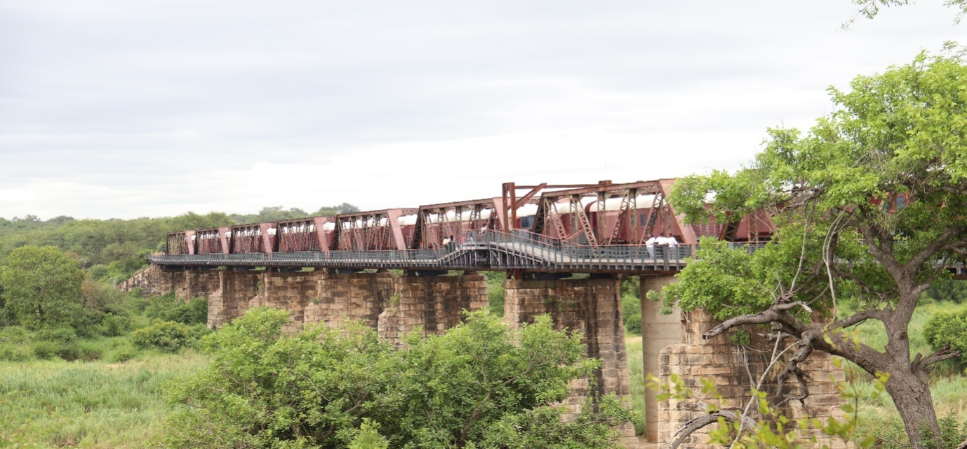

Traditional leaders were also taken to Mdluli Safari Lodge which is a community owned lodge within Kruger National Park. This lodge is under the Traditional leadership of Inkosi Mdluli, in an area now known as the Mdluli Reserve located within the borders of the Park. The Mdluli Community has a freehold title of 850 hectares of land inside the borders of the Kruger National Park. The Community receives direct and indirect social and economic benefits from the lodge’s operations. This lodge is commercialised and owned through a 50/50% partnership with the local Mdluli Community. The lodge was developed with the purpose of sustainably improving the lives and infrastructure of the 45 000-members of Mdluli Community that reside within 4 villages at the Mdluli Reserve.

Traditional leaders also travelled to Bela Bela CPA in Limpopo with the aim of viewing some of the projects owned by the Bela Bela Community. Bela Bela CPA is claimed land situated in Limpopo Province under the Bela Bela Municipality. This CPA is regarded as one of the very successful land claim stories of land claimed in 1998.. When the Mabula community’s land claim was finalized, they resolved to do things differently and they are now reaping the rewards of their decision. Amongst the things that they have done, is to dedicate a portion of the land to include a game lodge, cattle and crop farming, as well as egg/poultry farming and eco-tourism, which in turn has has created job opportunities for the community.

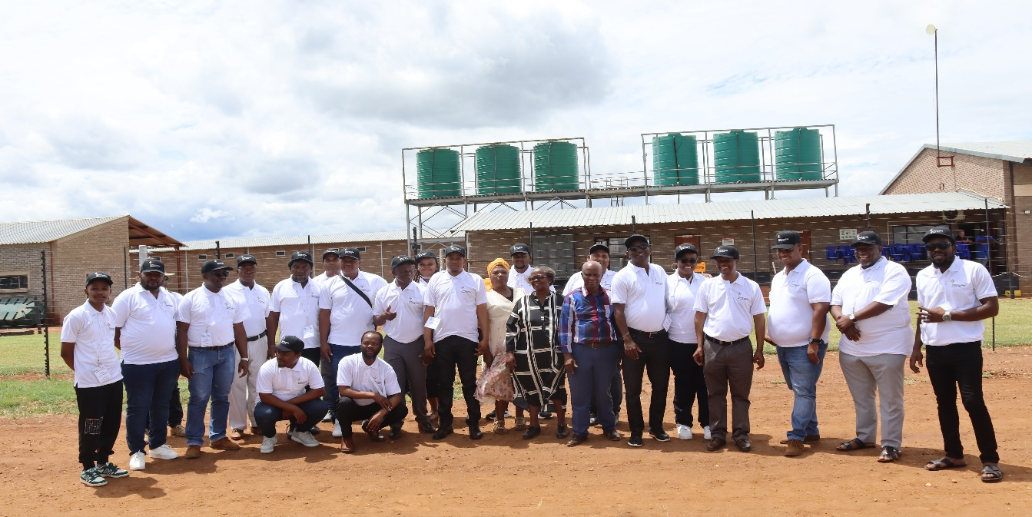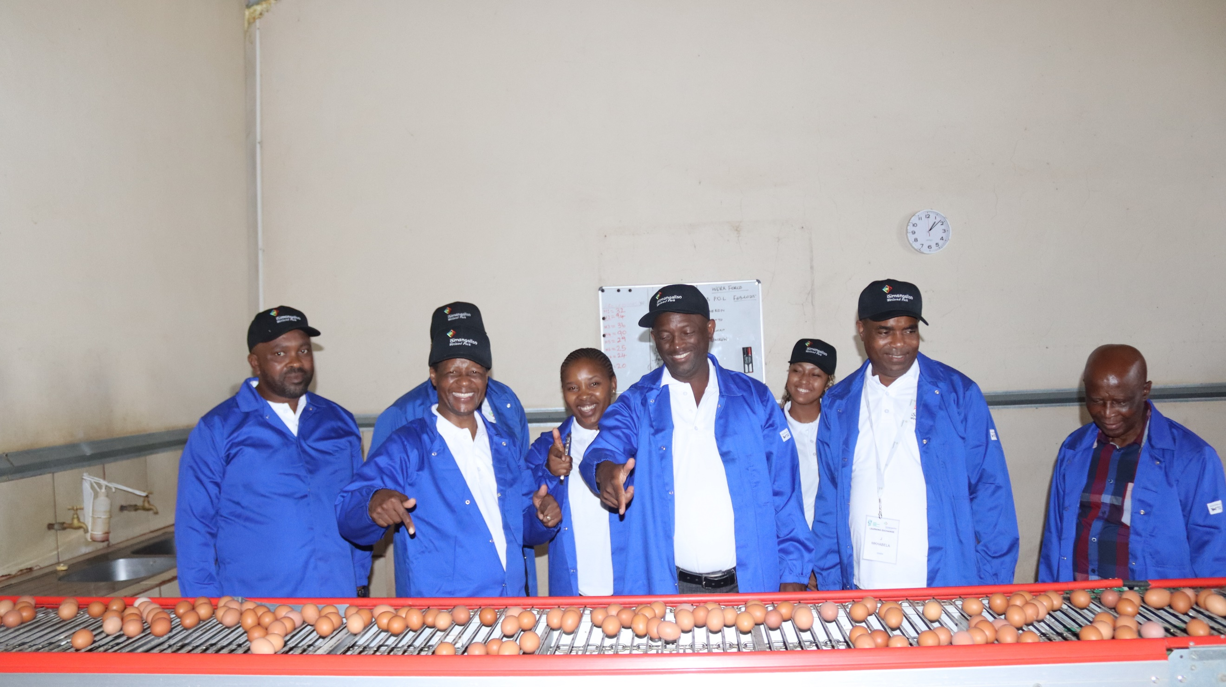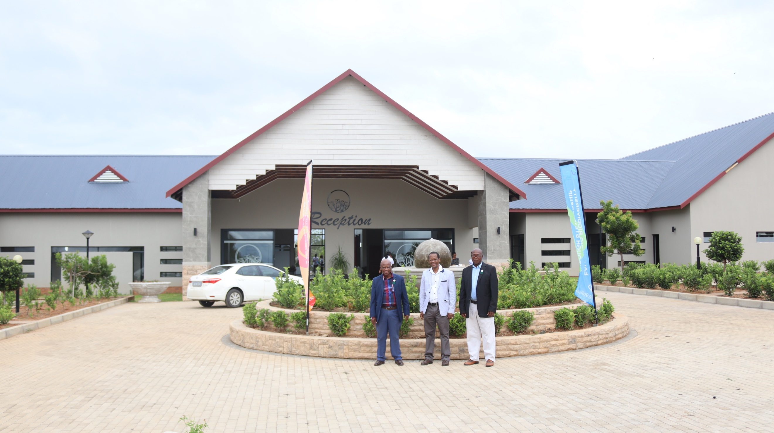

The eggs produced at the farm are collected by Eggspert Eggs which grades, packages and supplies them to chain stores like Pick n Pay, Shoprite and Checkers, among others. Bela Bela CPA is considered as one of South Africa’s most successful land restitution and development models that has significantly restored the dignity of previously disadvantaged people and fought against poverty. The CPA has a community beneficiation programme that provides each household with 12.5 kg of maize meal, a bag of mixed vegetables, red/white meat including game meat, eggs, rice, and fish each month. Community members also receive Christmas hampers and, when profits allow, a cash bonus of up to R10,000 per family. As well as providing internships, undergraduate placements, mentorships and learnerships. The Traditional leaders also visited some of the lodges owned by Bela Bela CPA.

***Video 2 to be inserted***

The uMkhanyakude District Chairperson of Traditional leaders, Inkosi Gumede, expressed his gratitude and appreciation to the CEO of iSimangaliso Wetland Park Mr Bukhosini for convening an eye-opening initiative for Traditional leaders. “As I look at these projects implemented by Bela Bela CPA, led by our colleague Chief Mabuela, I think we are too behind. I appreciate that all Traditional leaders are present, all we must do is to go back home and come up with business ideas that we must do to improve the livelihood of our communities.”

The CEO of iSimangaliso Wetland Park Authority, Mr Sibusiso Bukhosini addressing one of the sessions with Traditional leaders at Limpopo, highlighted that if Traditional leaders can work closely with experts in the field of biodiversity economy, there is a lot that can be achieved. “I grew up being told that uMkhanyakude is a poverty node and even till this day, uMkhanyakude is still characterised as such. This won’t change until we as stakeholders do something. If Chief Mabuela has done it, I believe that Traditional leaders within uMkhanyakude District can achieve even more by working closely with government structures such as iSimangaliso Wetland Park Authority”.

This learning exchange comes after iSimangaliso hosted a four-day community learning exchange at Hluhluwe from the 10th to the 13th of September 2024. This learning exchange was hosted with the purpose of familiarizing communities living in and adjacent to iSimangaliso Wetland Park about biodiversity stewardship under the theme Building Biodiversity Economy Nodes for Community Stewardship and Livelihoods*.* Amongst the dignitaries that attended this learning exchange the previous year, were the 13 Traditional leaders from uMkhanyakude District, 14 land claimants, DFFE, SANBI, WWF, and Ezemvelo, District and Local Municipalities within uMkhanyakude District. iSimangaliso stakeholders requested that iSimangaliso should organize a site visit for all Traditional Leaders within uMkhanyakude District and Sokhulu to visit and learn more about the strategy used by Bela Bela CPA that led to their success in business.

The presentation from Bela Bela Communal Property Association (CPA) played a crucial role in capturing the attention and interest of community leaders. The Bela Bela presentation mostly addressed issues and challenges faced by the majority of iSimangaliso stakeholders. Amongst the discussions held, it was clear that most of the local stakeholders are involved in farming activities, and that the land they would like to put forward for stewardship is currently used for grazing their cattle. Stakeholders vigorously engaged with the CEO of the Bela Bela CPA, Chief Barrington Mabuela with the aim of learning strategic ways that will help them continue faming while participating in the biodiversity stewardship programme.

**-End-**

**Statement issued by iSimangaliso Wetland Park Authority**

**For Media enquires**

MLO: Mr Bheki Manzini

Call/WhatsApp: 060 533 2082

Email: bhekimanzini@isimangaliso.com