

# 12 kuZibandlela 2024

iSIMANGALISO SIKULUNGELE UKWAMUKELA ABAVAKASHI KULESI SIKHATHI SAMAHOLIDI

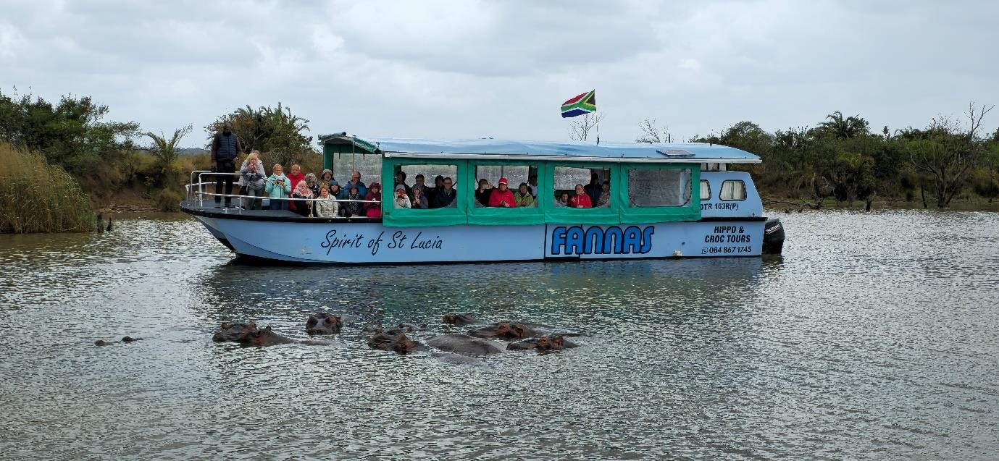

iSimangaliso Wetland Park singezinye yezindawo ezinobuhle bemvelo kuleli lase-Afrika. Kulo nyaka, iSimangaliso sihlanganisa iminyaka engamashumi amabili nanhlanu selokhu saqokwa ukuba yinhlangano ebhekelela ukuvikela kanye nokongiwa kwemvelo, iqokwa yinhlangano eyaziwa ngokuthi yi-UNESCO ngoZibandlela wonyaka ka-1999, lokho kwenza ukuthi kulo nyaka kubungazwe ukuzalwa kwePaki elikhulukazi ngoba linobubanzi bendawo elinganiselwa ku-1314 539 ha, okuwukuthi sisuka eMaphelane size siyofika eKosi Bay eduze nomengcele wase-Mozambique, sinemvelo ehlukahlukene kanye nezindawo ezinhle kakhulu. Igama elithi, “iSimangaliso” lichaza isimanga sobuhle bemvelo obukushiya ungawuvali umlomo, okuwukuthi ngokwanele le ndawo ichazeka njengehlukile kwezinye ezikhona.

iSimangaliso Wetland Park siyintandokwazi kubavakashi abaningi abafika kuleli ngenhloso yokuzobona ubuhle bemvelo, njengoba sazeka ngokuba nemvelo ehlukahlukene okufaka phakathi esolwandle, egudle ugu lolwandle, amaxhaphosi, isizalo sechweba kanye nemvelo ekhona emhlabeni. Abavakashi abavela kuwo wonke umhlaba bangathokozela okuhlukahlukene ngaphakathi ePaki okuwukuthi kukhona okutholakala olwandle nokutholakala esiqiwini. Ngonyaka ophelile nje kuphela, bangaphezu kuka-172 600 abavakashi abangene emagedeni eSimangaliso Wetland Park, lezi zibalo azibafaki labo ababengena kodwa bengakhokhi okufaka phakathi umphakathi wendawo. iSimangaliso Wetland Park sikwazile ukugcina igama lokuba yisiphephelo sezokuvikelwa kwamagugu omhlaba kule minyaka engamashumi amabili nanhlanu adlule. Lokhu kuwubufakazi kwezokongiwa kwemvelo, ukusebenza ngokubambisana nomphakathi kanye nokwenza ezokuvakasha ezinozinzo. Lokhu kusabalala kuze kweqe imingcele ebekiwe, kuthinte izimpilo zabantu bomphakathi kanye nabavakashi imbala.

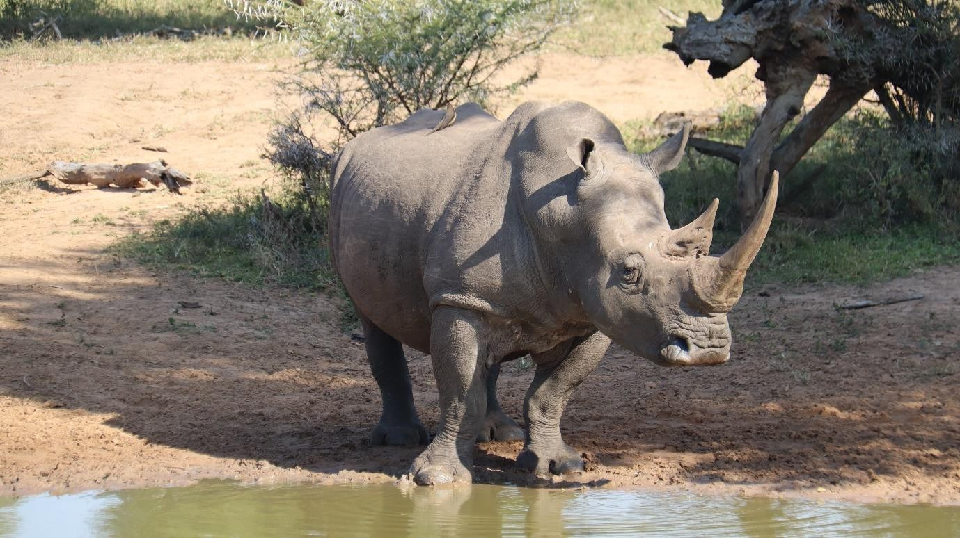

Isikhathi samaholidi sesifikile, imindeni, abangani kanye nabo bonke abantu abasondelene bathatha lesi sikhathi ukuvakashela izindawo abazithandayo ukuzohlukanisa unyaka. Ezokuvakasha ezazeka umhlaba wonke ezenziwa eSimangaliso lapho kuba nemijikelezo yokufunda ngezimfudu okuwuhlelo oluqala ngo Lwezi luze luphele ngoNdasa luqondana nokuthi sesiqalile isikhathi samaholidi.

Abavakashela iSimangaliso banokuningi abangakhetha kukho kulobu buhle obuyisimanga obutholakala ePaki. Amabhishi asesimeni esingathokozelwa izinkulungwane zabavakashi abathanda ukubhukuda kanye nokungena ngaphansi kwamanzi njalo njalo. iSimangaliso, indawo ewubufakazi bemvelo ehlukahlukene, ekushiya umangele. Ukuntweza ngaphansi kwamanzi kuyenziwa eSimangaliso kwingxenye yePaki eseSodwana Bay okuyindawo edume kakhulu ngakho ukuntweza ngaphansi kwamanzi, uma unokudideka mayelana nokuthi kumele uphathe ini uma uvakashela iPaki, kumele ube nokwasezinyaweni okuzokwenza uzizwe ukahle, ube nokokuzivikela elangeni (sunscreen), isigqoko selanga, izipopolo, ikhamela kanye nejakhethi ukuze uma sekubanda ntambama ungakhathazeki, ungakhohlwa okokuzivikela komiyane. Okokubhukuda kanye nesigqoko kuyaphoqa ukuthi ube nakho.

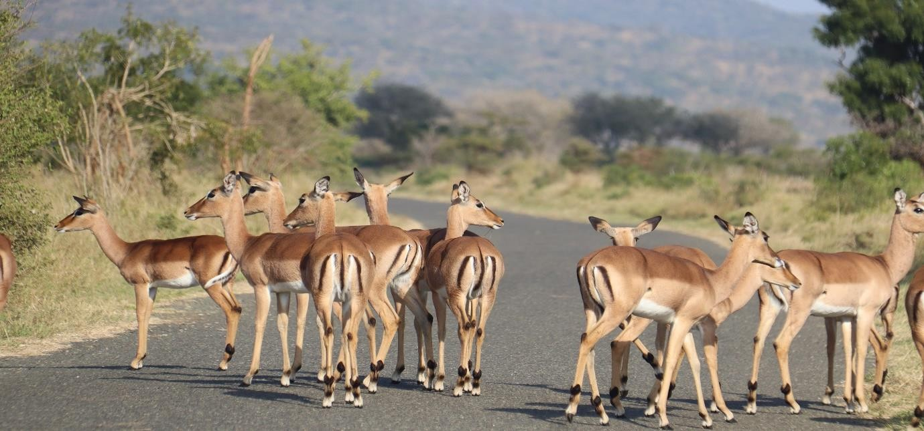

Yilokho okudingakala ukuba ukuphathe ukuze uzojabulela ukuba sePaki kanye nolwandle. Kuba nesikhathi lapho kuvakashelwa izindawo ezigudle ugu ezifana neCape Vidal, Perries Rocks, eLala Nek, eKosi Bay mouth, eMabibi, kanye nase-Black Rock. ESimangaliso kugcwele ubuhle obumangazayo, izindawo lapho ubuka ubuhle bemvelo uphezulu esicongweni. Kunezindawo ngaphakathi ezinokuthula kulabo abangazwani nendawo enomsindo. iSimangaliso sikulungele ukukuhlaba umxhwele ngobuhle bemvelo obutholakala ePaki.

-Iyaphela-

**Isitatimende sikhishwa iSimangaliso Wetland Park Authority**

**Abezindaba bengaxhumana no:**

MLO: Mnuz. Bheki Manzini Call/WhatsApp: 060 533 2082

Email: [bhekimanzini@isimangaliso.com](mailto:bhekimanzini@isimangaliso.com)