

02 kuZibandela 2024

UKONGIWA KWEMVELO NGAPHANDLE KWEMINGCELE-IZIMFUDU ZITHOLA IKHAYA ELISHA

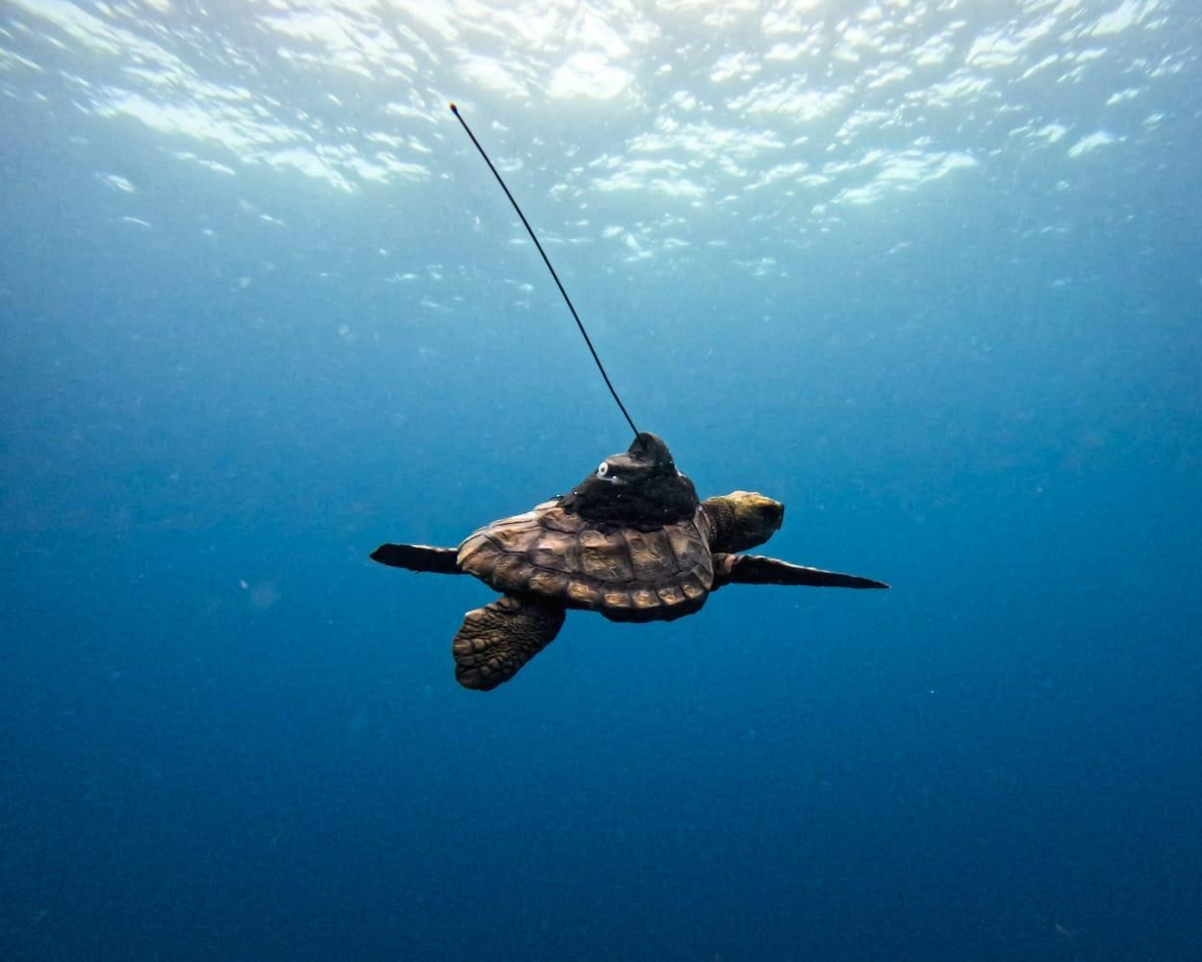

*Ufudu oluseluncane olwabonakala eSodwana.*

Isikhathi sezimfudu sesifikile eSimangaliso Wetland Park, futhi sekuqaliwe ukwenziwa ezokuvakasha ezimayelana nazo izimfudu. Lolu hlobo lwezokuvakasha luheha kakhulu abavakashi abavela kuwo wonke amazwe omhlaba ukuthi beze kule ndawo yamagugu omhlaba. Kungekhona kodwa ukuthi lolu hlobo lwezokuvakasha luhle kakhulu, kodwa luphinde lunike abavakashi ithuba lokuthi befunde ngemizamo eyenziwa yipaki ukuvikela imvelo, kube kubhekelelwa izimfudu. Mukhulu umsebenzi owenziwe ukulondoloza le mvelo ukuze kuqinisekiswe ukuthi lobu buhle buyagcinwa ukuze buzobonwa izizukulwane ngezizukulwane.

iSimangaliso sisanda kubambisana nezinye izinhlangano ezahlukahlukene kanye nama-*NGOs* okufaka phakathi i-*Two Oceans Aquarium Foundation*, emizameni yokuphinde kuqaliswa ukuvikelwa kwezimfudu zasolwandle ezitholakala eSodwana Bay. Kube yinjabulo mayelana nokudedelwa kofudu olwaziwa ngokuthi ngu-*Bokkie*, ufudu olukuhlazana lwasolwandle, ne-*Luna*, kanye nezinhlobo zezimfudu eziyishumi nambili ezaziwa ngokuthi ngama-*Loggerhead*. Lolu fudu okuthiwa ngu-*Bokkie* luhlale unyaka luhlengwa ngemuva kokuthi lutholwe ngabe-*Turtle Rescue Network* eStruisbaai lapho lwase luyinhlwa khona. Kususwe okuyisisindo esilinganiselwa ku-800 grams emhlane walolu fudu kanye nokuyizinsalela zoshekhasi ezingamashumi amane nesikhombisa, konke lokhu kwenziwe yithimba lezokuvikelwa kwemvelo elaziwa ngokuthi yi*-Two Oceans Turtle*.

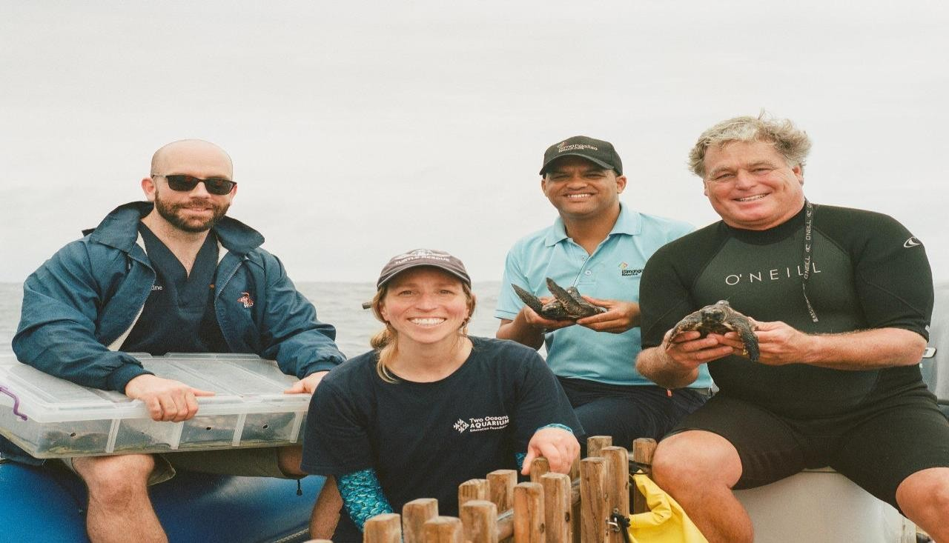

*Kusuka kwesokunxele, yilungu le-SAAMBR, kube ngele-Two Oceans, eleSimangaliso kanye ne-Upwell.*

Ngomhlaka 21 kuMfumfu 2024, oyi Ecologist leSimangaliso Wetland Park uDr. Riaan Cedras wayekhona ukuzokwamukela izihambeli ezivela kwa-*Two Oceans,* kwa-*SAAMBR*, kwa-*Upwell* kanye Nezemvelo KZN Wildlife, kwakuhlanganelwe eSodwana Bay, kanye nazo izimfudu. Kwakubanjiswene ukuthi kuqinisekiswe ukuphepha kwazo njengoba kwadilizwa eziyishumi nanye okwakumele zidedelwe, kwakumele kubhekisiswe uBokkie. Zonke izimfudu zazinamathegi, futhi ngokwalabo ababheka ukuhamba kwazo izimfudu ezinamathegi, babona ukuthi uBokkie ngenkathi ededelwa wabe esenyuka elibangisa ngenhla ngase Kosi Bay okuyingxenye esenyakatho yePaki okuyilapho kubukeka lolu fudu luthokozela amanzi afudumele olwandle olwaziwa ngokuthi yi-*Indian ocean.*

iSimangaliso’s MPA inezindawo ezingashoni kakhulu, amanzi agelezela emachwebeni kanye nesizalo sechweba. iPaki liphinde laziwe njengekhaya lamachweba abaluleke ngokusezingeni lomhlaba (RAMSAR) okuyindawo yamakhorali kanye nezimfudu ikakhululazi eTongaland. Sekuyisikhathi esilinganiselwa kwinyanga selokhu kwadedelwa lezi zimfudu, ngokwalabo ababheka ukuhamba kwazo, zithokozile kakhulu kulolu lwandle 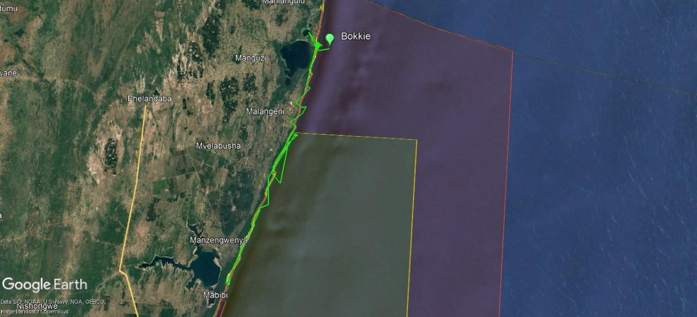njengoba ziphinde zehlele ngezansi kolunye ulwandle oluyi Atlantic Ocean.

*Okukhombisa uhambo lwamaBokkies selokhu adedelwa mhlaka 21 kuMfumfu 2024.*

Izimfudu zasolwandle zinomsebenzi omkhulu ukugcina isimo solwandle sisesimeni esikahle, kunomsebenzi omkhulu eziwenzayo olwandle. Zineqhaza elikhulu ekwakhekeni kwama khorali kanye nokuthutha okubalulekile okutholakala ngaphakathi olwandle zikuyise ngaphandle kulezi zindunduma ezigudle ulwandle. Noma kunjalo, zikhona izinselelo ezibhekene nalezi zilwane ngenxa yokudotshwa kwazo, ukungcoliseka kolwandle kanye nokuguquka kwesimo sezulu. Lamanzi afudumele atholakala olwandle olunengxenye engaphansi kweSimangaliso, kuhlala izinhlobonhlobo zezimfudu, okufaka phakathi nofudu olusengcupheni yokuphela olwaziwa ngokuthi yi-*Leatherback* kanye ne-*Loggerhead*.

iSimangaliso sinendawo elinganiselwa ngaphezu kuka-1 328 000 hectares evuleke ngaphezu kuka-220 km egudle ulwandle kuze kuyofika emngceleni wase-*Mozambique.* Indawo evikelwe inengxenye ebaluleke kakhulu ePaki okuwukuthi minyaka yonke, lezi zimfudu ziyeza kuleli zikhuphukele kwingxenye esenyakatho ukuba ziyozalela lapha ePaki. Izimfudu ezizalelayo zihlezi zibuya ezindaweni lapho zazalelwa khona ukuthi nazo zizozalela amaqala, yingakho kubemqoka ukuthi uBokkie abuyele lapho akhulela khona.

Akusathusi ukuthi iPaki lihlezi liseqhulwini ekongiweni kwemvelo ngazikhathi zonke, iSimangaliso Wetland Park sithenjiwe ngokuqhubeka nomsebenzi wokuvikela imvelo kanye nokubambisana nezinhlangano ezingenzi nzuzo, njengoba kume kanje, ziyisithupha izinto ezenza iSimangaliso sibe isiphephelo kwezokongiwa kwezimfudu okuyilezi:

1. Ukuphoqelela ukugcinwa komthetho

iSimangaliso siqinise umthetho mayelana nokuzingelwa kwezimfudu esezindala kanye nokuthathelwa amaqanda azo

1. Ukuqapha ukuzalela kwezimfudu

iSimangaliso siqapha kakhulu ukuzalela kwezimfudu minyaka yonke ukuqinisekisa ukuthi amachwane abuyela olwandle ephephile.

1. Ukudala izindawo ezivikelwe

iSimangaliso Wetland Park samemezelwa njengendawo eyi-*Marine Protected Area (MPA*). Lokho kwenzela ukuvikela ukuzalela kwezimfudu kanye namachwane ezimfudu kulabo abangawathatha.

1. Ukuqinisa umthetho ngokuthi kube khona abalandelelayo

iSimangaliso sinamaphoyisa abheka ugu lapho kuzalela khona izimfudu, abheka ubusuku nemini makuvela isidingo.

1. Ezokuvakasha ezihambisana nokubukwa kwezimfudu

iSimangaliso sinazo ezokuvakasha ezihambisana nokubukwa kwezimfudu kanye nokubukwa zizalela.

1. Imicimbi lapho kudedelwa khona izimfudu ukuba zibuyele emuva

iSimangaliso sidedela izimfudu ezisencane ukuba zingene ngaphakathi.

NgokweSimangaliso Wetland Park Authority, ukuvikelwa kwemvelo ngaphandle kwemingcele kusho ukuthi iPaki liba sezingeni eliphezulu, okugqugquzela ukuthi kube noshintsho kwimvelo, kungabhekwa ukuthi itholakala kuphi nomhlaba.“ukuhlanganyela okuwulolu hlobo, kuletha umuzwa wokuthi siziqhenye ngePaki,njengoba lokhu kusikhumbuza ukuthi umsebenzi esiwenzayo uneqhaza elikhulu ngaphezu kwemingcele yeSimangaliso,’’ kusho umphathi omkhulu weSimangaliso Wetland Park, Mr. Sibusiso Bukhosini. Kuyimpumelelo enkulu lokhu, ukuba iPaki libe sebalazweni lo mhlaba mayelana nokuhlanganyela ndawonye nezinye izinhlaka ngenhloso yokuvikela imvelo, kube kunentshisekelo enkulu yokuvikela amagugu omhlaba atholakala ePaki ukuze isizukulwane samanje nesizolandela sizowazi.

**-Iyaphela-**

**Isitatimende sikhishwa iSimangaliso Wetland Park**

**Abezindaba bengaxhumana no:**

MLO: Mr. Bheki Manzini Call/Whatsapp: 060 533 2082

Email: [bhekimanzini@isimangaliso.com](mailto:bhekimanzini@isimangaliso.com)