

**FOR IMMEDIATE RELEASE**

**31 MARCH 2025**

**DROWNING INCIDENT AT ST. LUCIA JABULA BEACH**

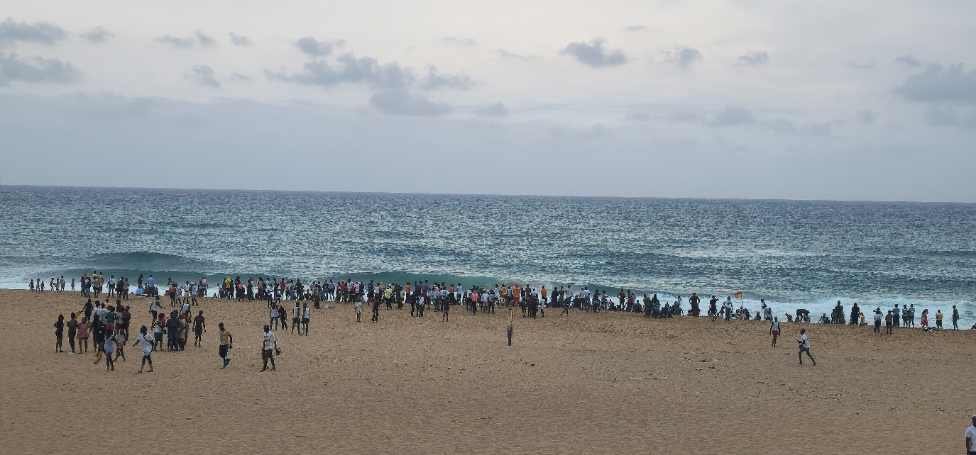iSimangaliso Wetland Park Authority would like to confirm the drowning of an african male of about 21 years of age at St. Lucia Jabula beach on Sunday the 30th of March 2025.

According to the preliminary reports received, 3 bathers experienced some difficulties while swimming, the two managed to swim to safety and one was swept away by the rip current. The National Sea rescue Institute (NSRI) was called in for intervention, unfortunately the body could not be recovered at the time.

iSimangaliso Wetland Park would like to express its deepest condolences to the family and friends of the missing person.

**-End-**

**Statement issued by iSimangaliso Wetland Park Authority**

**For Media enquires**

MLO: Mr Bheki Manzini

Call/WhatsApp: 060 533 2082

Email: bhekimanzini@isimangaliso.com