

**FOR IMMEDIATE RELEASE**

**22 April 2025**

**WORLD BANK VISITS GEF-7 PROJECTS WITHIN iSIMANGALISO WETLAND PARK**

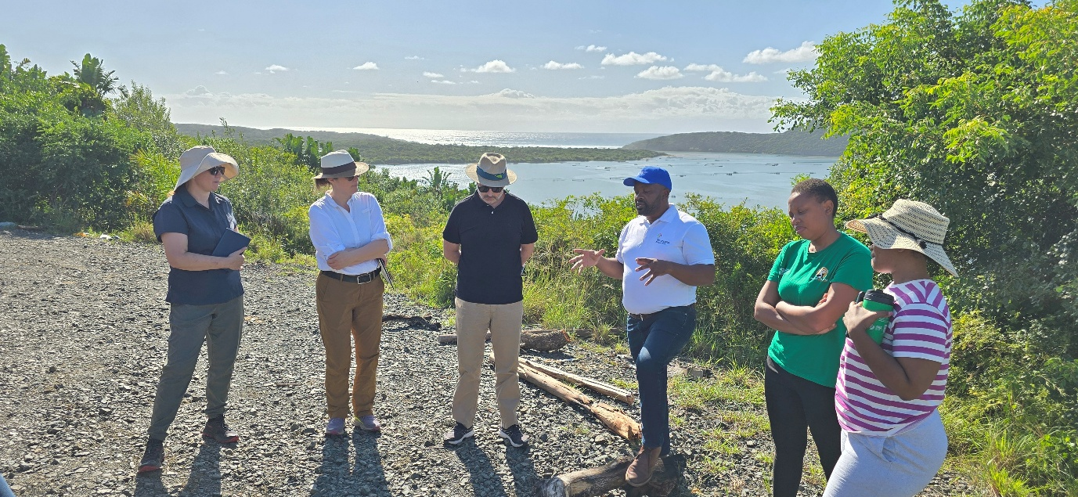

The iSimangaliso Wetland Park through the GEF-7 Project, hosted the delegation from World Bank and the Department of Forestry, Fisheries and the Environment (DFFE) on a site visit with the aim of viewing projects that are assisted and implemented by the funding from the World Bank. One of the key elements of the GEF-7 Project is to use this funding as a catalyst to finance capacity for the Biodiversity Economy centred around the Protected Areas Project. The areas that were visited during the four days site visit are Kosi Bay tourism precinct (Madlangula Boat concessioners, Madlangula lodge, KwaDapha homestays, and the Kosi Bay Mouth), Mabasa, Makhasa and Nibela. The delegation from DFFE and World Bank not only visited all the GEF-7 project sites but also met with the beneficiaries and community members to further engage on the challenges as well as the progress of the project, and highlighted the impact brought by iSimangaliso through the implementation of the GEF-7 projects in their communities. Various opinions were raised during discussions.

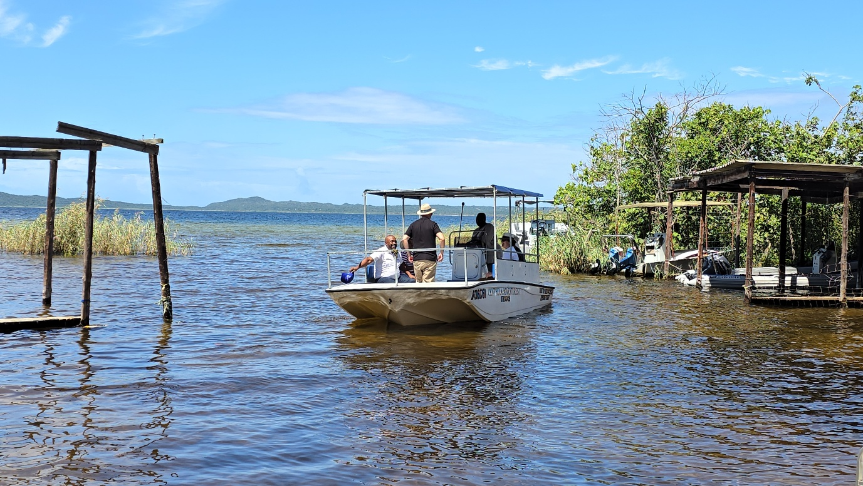

iSimangaliso is one of the implementing agencies of the GEF-7 projects that focuses on developing biodiversity economy nodes for community stewardship and livelihoods in and around South Africa’s Protected Areas. This project intends to assist Kosi Bay tourism precinct with the Master Plan, that includes the rehabilitation of the Madlangula lodge, supports three Madlangula boat concessionaires with new boats and renovate six homestays in KwaDapha. The World Bank together with GEF-7 team visited kwaDapha to meet with the community and view the state of homestays that will be rehabilitated by iSimangaliso through the GEF-7. The team then visited Kosi Mouth to view the identified possible project site to build an eco-friendly high end accommodation facility of which the Master Plan for this project is ongoing.

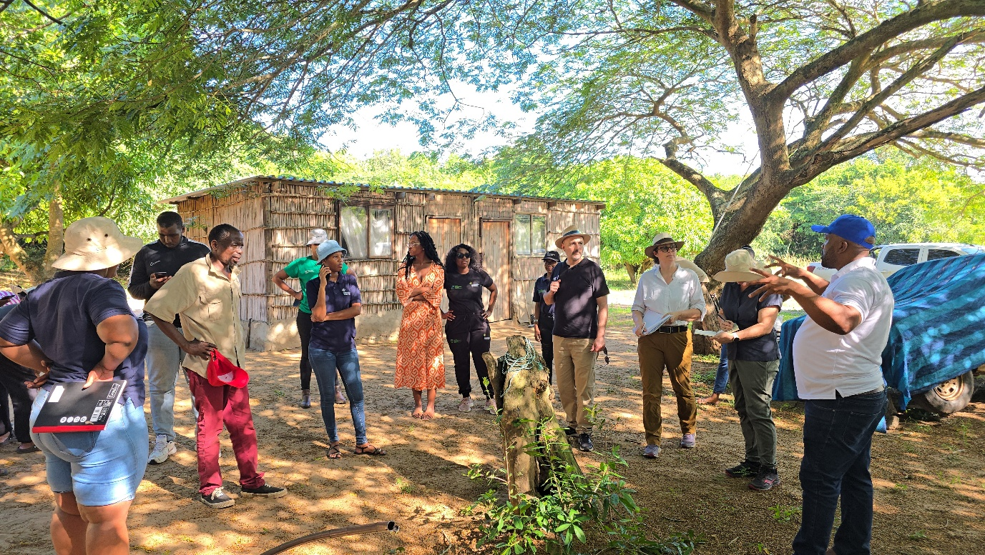

The GEF-7 project is currently in the process of having the three Community Conservation Areas namely: Mabasa CCA, Makhasa CCA and Nibela CCA, to be declared as Conservation Areas or Nature reserves. These CCA’s will also be assisted with game donations, and infrastructure development etc..

Improving the livelihood of communities neighboring iSimangaliso remains one of the key objectives for iSimangaliso Wetland Park. The GEF-7 project and iSimangaliso have already implemented some of the above-mentioned projects and community members are already benefiting from these projects. The team visited Madlangula Boating Concessions to view the state of boats that are owned by the community and how they operate. These beneficiaries were trained and have received their boating permits through the SMME’s programme of iSimangaliso Wetland Park. Two boats have already been delivered to one of the concessioners at Madlangula and two more boats will be delivered over the next 2 months. The GEF-7 project will also assist them by building a boat harbour where they will receive their passengers. In October 2024, Makhasa CCA received Leadership and Governance training from iSimangaliso, and other trainings are scheduled for 2025. Furthermore, 12 Giraffes have been donated to Makhasa CCA.In 2025, biodiversity assessments that will assess the biodiversity value which will determine the stewardship category that Makhasa CCA, Nibela CCA and Mabasa CCA qualify for.

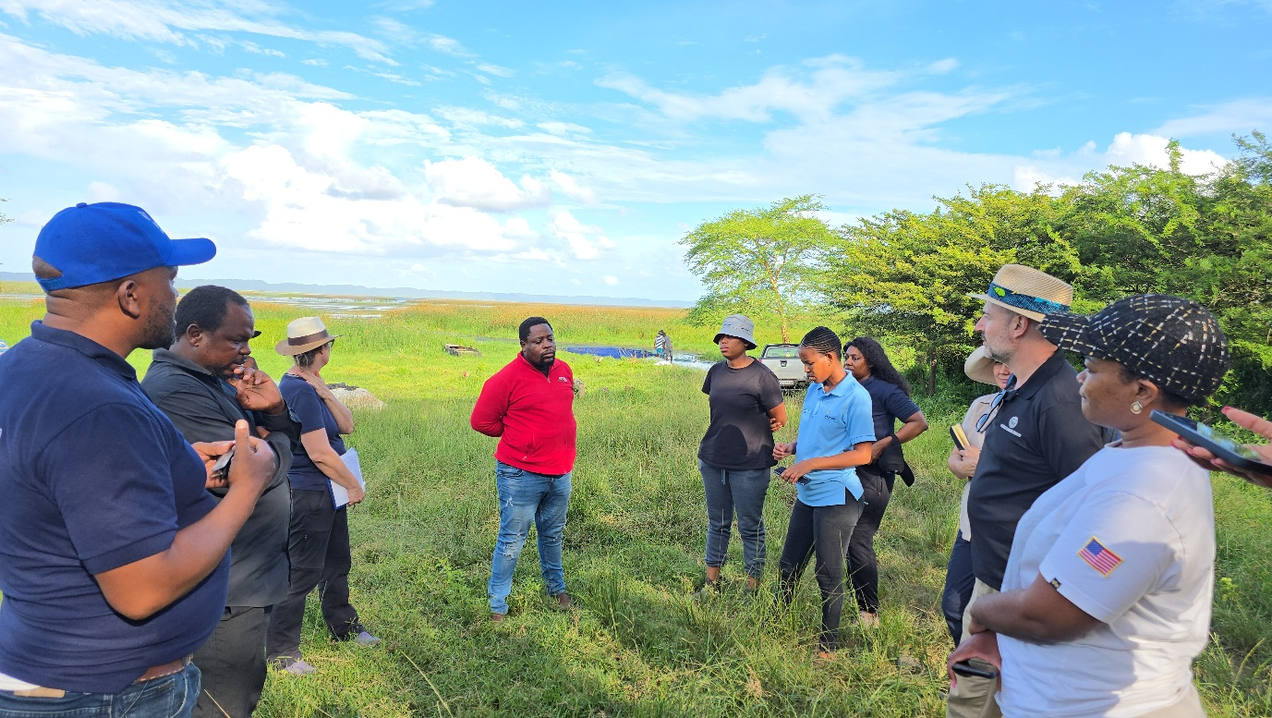

The World Bank delegation is satisfied with the progress of the GEF-7 project within iSimangaliso Wetland Park Node, that seeks to build biodiversity economy nodes for community stewardship, improve livelihoods and grow the biodiversity economy nationally to enhance communities’ stake in the wildlife conservation space.

**-End-**

**Statement issued by iSimangaliso Wetland Park Authority**

**For media enquiries:**

MLO: Mr Bheki Manzini

Call/WhatsApp: 060 533 2082

Email: bhekimanzini@isimangaliso.com