**FOR IMMEDIATE RELEASE**

**27 MAY 2025**

**CONSERVATION ORGANISATIONS IN COLLABORATION TO RAISE OCEAN CONSERVATION AWARENESS THROUGH COMMUNITY HUBS**

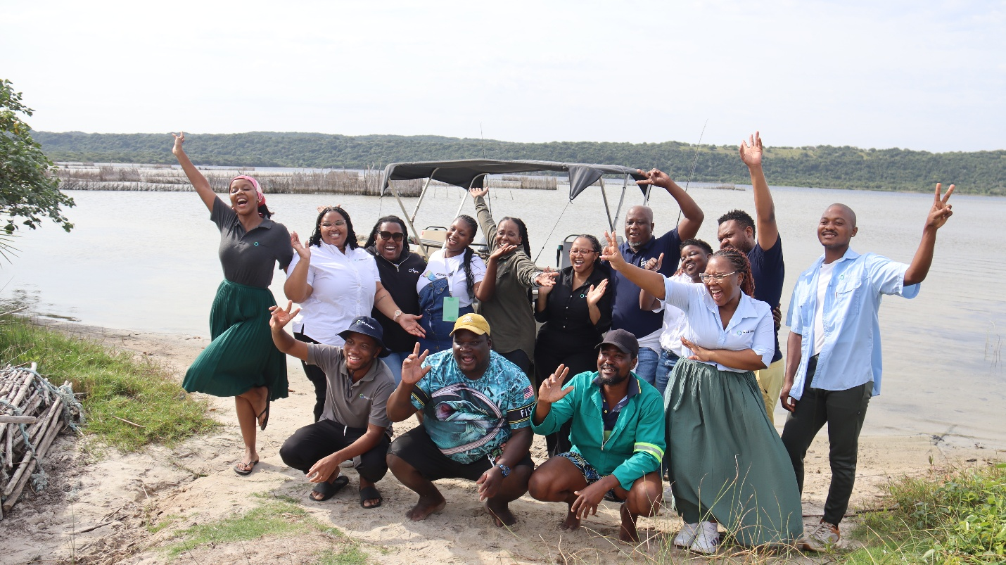

iSimangaliso Wetland Park Authority collaborating with its Marine Protected Area (MPA) Ecosystem-based Adaptation (EbA) partners WILDTRUST Project hosted a two-day media tour with an aim of profiling the great work done that is taking place through iSimangaliso and WILDTRUST partnership in addressing environmental issues such as Climate change through the adoption of EbA approaches within the MPA and surrounding communities.

The project seeks to enhance iSimangaliso environmental conservation programmes in and around the World Heritage Site known as iSimangaliso. The Media Hosting offered a unique opportunity to witness the impact and the work that has been achieved through the iSimangaliso MPA EbA project on both the environment and local communities.

The Media had an opportunity to visit some of the projects that are being implemented by WILDTRUST project within the Park. The Media was taken to KwaDapha Community Resource Hub and had an opportunity to interact with community members to garner more insight about the project, the impact of the project and iSimangaliso to communities.

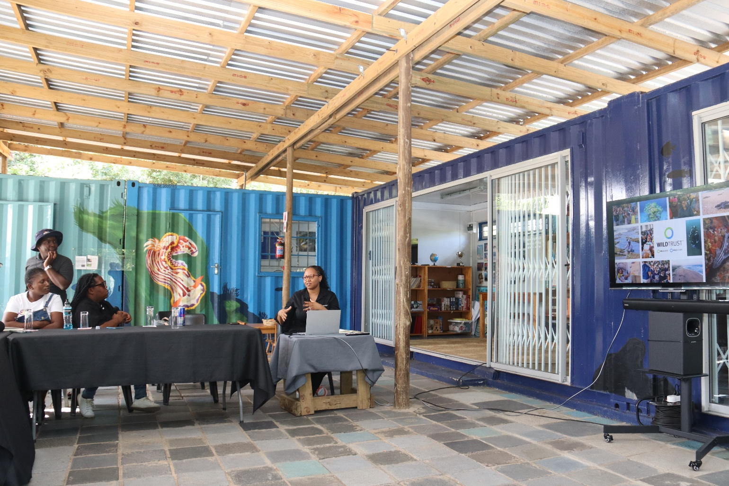In the engagements that took place during the tour, iSimangaliso Marketing Manager Ms Thandi Shabalala said through the leadership of the CEO of iSimangaliso Mr Sibusiso Bukhosini, there are a lot of efforts and work done by iSimangaliso to try and address some of the issues facing communities living in and adjacent to the Park. She delivered a presentation on the park's significance as South Africa’s first-proclaimed World Heritage Site and the largest terrestrial MPA.

The WILDTRUST’s MPA EbA Project Manager Ms Nozi Mbongwa while addressing the media said as WILDTRUST, they appreciate the ongoing relationship with iSimangaliso that kept yielding positive results that benefits communities, “The three community Hubs that are at Nkovukeni, KwaDapha & Mabibi within iSimangaliso assist communities with various activities that benefits communities including library, computer lab, these facilities are also used to host meetings and etc. WILDTRUST has created more than 27 permanent job opportunities for local community members living inside iSimangaliso Wetland Park

In the engagements that took place during the tour, iSimangaliso Marketing Manager Ms Thandi Shabalala said through the leadership of the CEO of iSimangaliso Mr Sibusiso Bukhosini, there are a lot of efforts and work done by iSimangaliso to try and address some of the issues facing

There are several projects that are implemented within iSimangaliso with an aim of improving the livelihoods of communities that lives in and around the Park. People should see the importance of conserving the natural resource through the various benefits that they reap through conservation.

**-End-**

**Statement issued by iSimangaliso Wetland Park Authority**

**For media enquiries:**

MLO: Mr Bheki Manzini

Call/WhatsApp: 060 533 2082

Email: bhekimanzini@isimangaliso.com